ESDE Assignment 1 Report

Member 1: Anna Yap (P1942789)

Member 2: Tenia Xu Yuan (P1935334)

Class: DIT/FT/2A/24

----------------------------------------------------------------------------------------------------------------

**Cloud Computing**

**1.0 | Step 1: Set up Ubuntu 18.04 on AWS EC2**

**1.1 | Create an Instance**

**1.2 | Connecting to the Created Remote Instance using Putty**

**2.0 | Step 2: Developing with Amazon S3**

**2.1 | Create a Bucket**

**2.1.1 | Install Node on EC2 Instance**

**2.1.2 | Start Server to run forever**

**2.2 | Enable Static Website Hosting**

**2.3 | Add Bucket Policy**

**2.4 | Upload files**

**2.5 | Test Website Endpoint**

**3.0 | Step 3: Create and Connect to a MySQL Database with Amazon RDS**

**3.1 | Create a RDS instance**

**3.2 | Connect RDS instance with MySQL Workbench**

**3.3 | Load SQL file into new connection to create database**

**3.4 | Configure database connection in EC2**

**3.5 | POSTMAN Testing**

**3.5.1 | Code Snippets**

**4.0 | Step 4: Developing with Amazon DynamoDB using AWS SDK**

**4.1 | Create Cloud9 Environment**

**4.2 | Create DynamoDB Table**

**4.3 | Upload / Add Items to a DynamoDB Table**

**4.4 | Populate Database**

**4.5 | Query for Item in DynamoDB Table**

**4.6 | Create GSI for DynamoDB Table**

**5.0 | Step 5: Developing with AWS Lambda and Amazon API Gateway**

**5.1 | Create Cloud9 Environment**

**5.2 | Create REST Endpoint with Amazon API Gateway**

**5.3 | Connect the New API (Mock) Endpoint to Website**

**5.4 | Enable CORS on the Endpoint**

**5.5 | Create a Lambda Function that Queries a Database**

**5.6 | Upload Lambda Deployment Package**

**5.7 | Call Deployment Package and Configure Lambda Function**

**5.8 | Testing Lambda Function**

**5.9 | Clean up AWS Cloud9 Environment**

**5.10 | Replace the REST API Mock Endpoint with New Lambda Function**

**5.11 | Re-Enable CORS**

**5.12 | Test Website**

**6.0 | Troubleshooting**

**6.1 | Elastic IP**

**6.2 | Putty SSH Connection Never to Timeout When User is Idle**

**6.3 | Error Running Command in Cloud9**

**6.4 | Error 502 CORS Headers Missing**

**6.5 | Can’t access DynamoDB from Lambda Function**

**6.6 | Node Version Outdated**

**6.7 | Unable to Login**

**6.8.1 | Unable to Show Item in Website Part 1**

**6.8.2 | Unable to Show Item in Website Part 2**

----------------------------------------------------------------------------------------------------------------

**1.0 Step 1: Set up Ubuntu 18.04 on AWS EC2**

**1.1 Create Instance**

1. Under AWS Services, select **“EC2”**

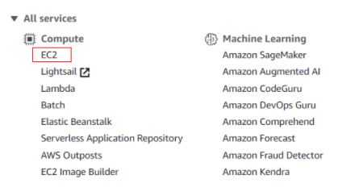

1. Select **“Instances”** -> **“Launch Instances”** (Found on top right of the screen)
2. In Step 1, search for **“Ubuntu Server 18.04”** and click **“Select”**

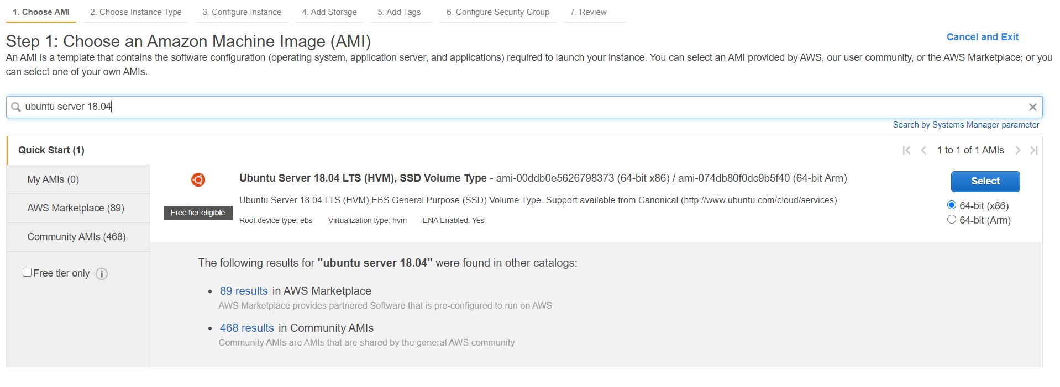

1. Step 2-5 can be kept as the default settings
2. In Step 6, “Configure Security Group”, change the source from ‘Custom’ to ‘My IP’ -> Click “Review and Launch” -> “Launch”

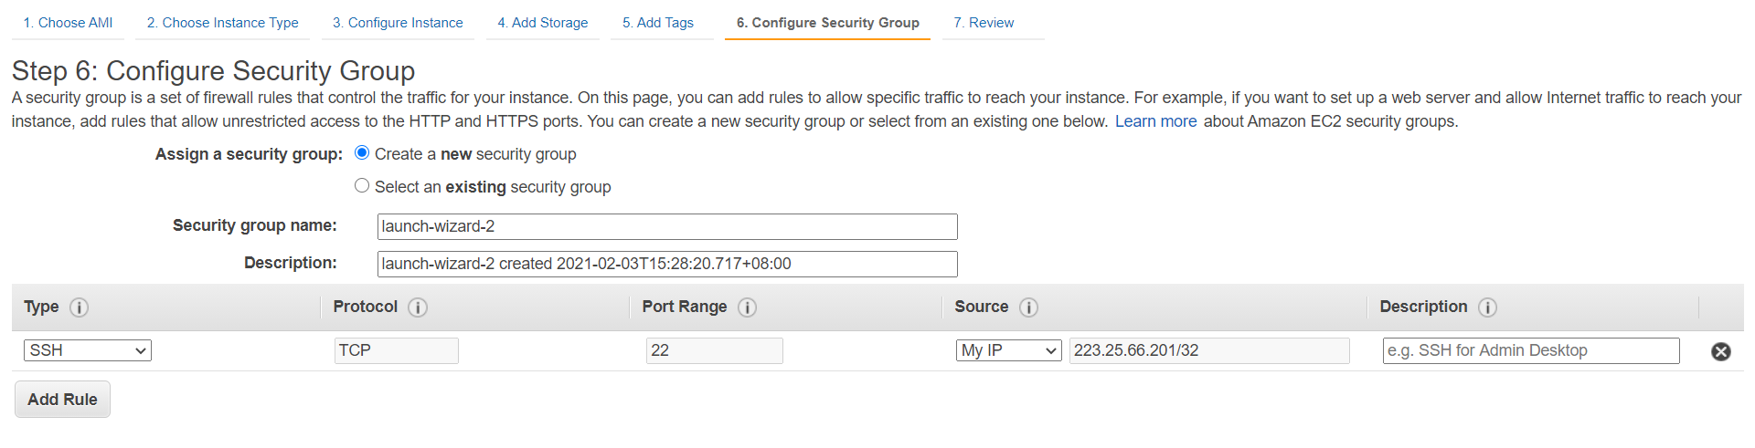

1. Create a new keypair and save it on your computer as ‘WPFOC-KETPAIR’. (Keep your keypair in a safe place, do not lose it!

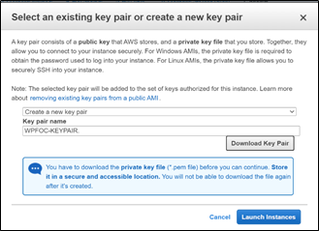

1. Launch instance

**1.2 Connecting to the Created Remote Instance using Putty**

1. Install [Putty](https://www.chiark.greenend.org.uk/~sgtatham/putty/latest.html)
2. By installing Putty, PuttyGen will also be installed. Open PuttyGen and select “File” -> “Load private key”.
3. Under **“Type of key to generate”**, choose **RSA.**  
   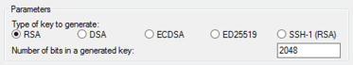
4. Choose **“Load”**. By default, PuttyGen displays only files with the extension *.ppk*. To locate your *.pem* file, select the option to display files of all types.  
   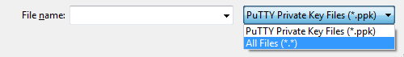
5. Select the *.pem* file for the key pair that you specified when you launched our instance and choose **“Open”**. Choose **“OK”**.

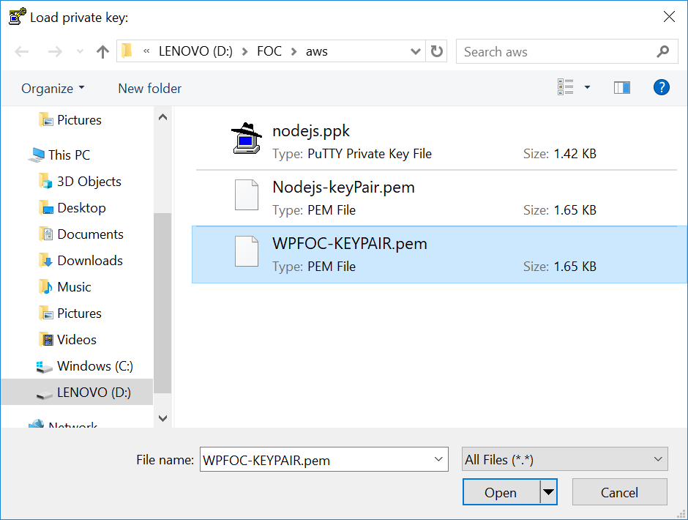

1. It will generate the private key. Select **“Save private key”** and name it as **“WPFOC.ppk”**. PuttyGen will display a warning about saving the key without a passphrase, choose **“Yes”**.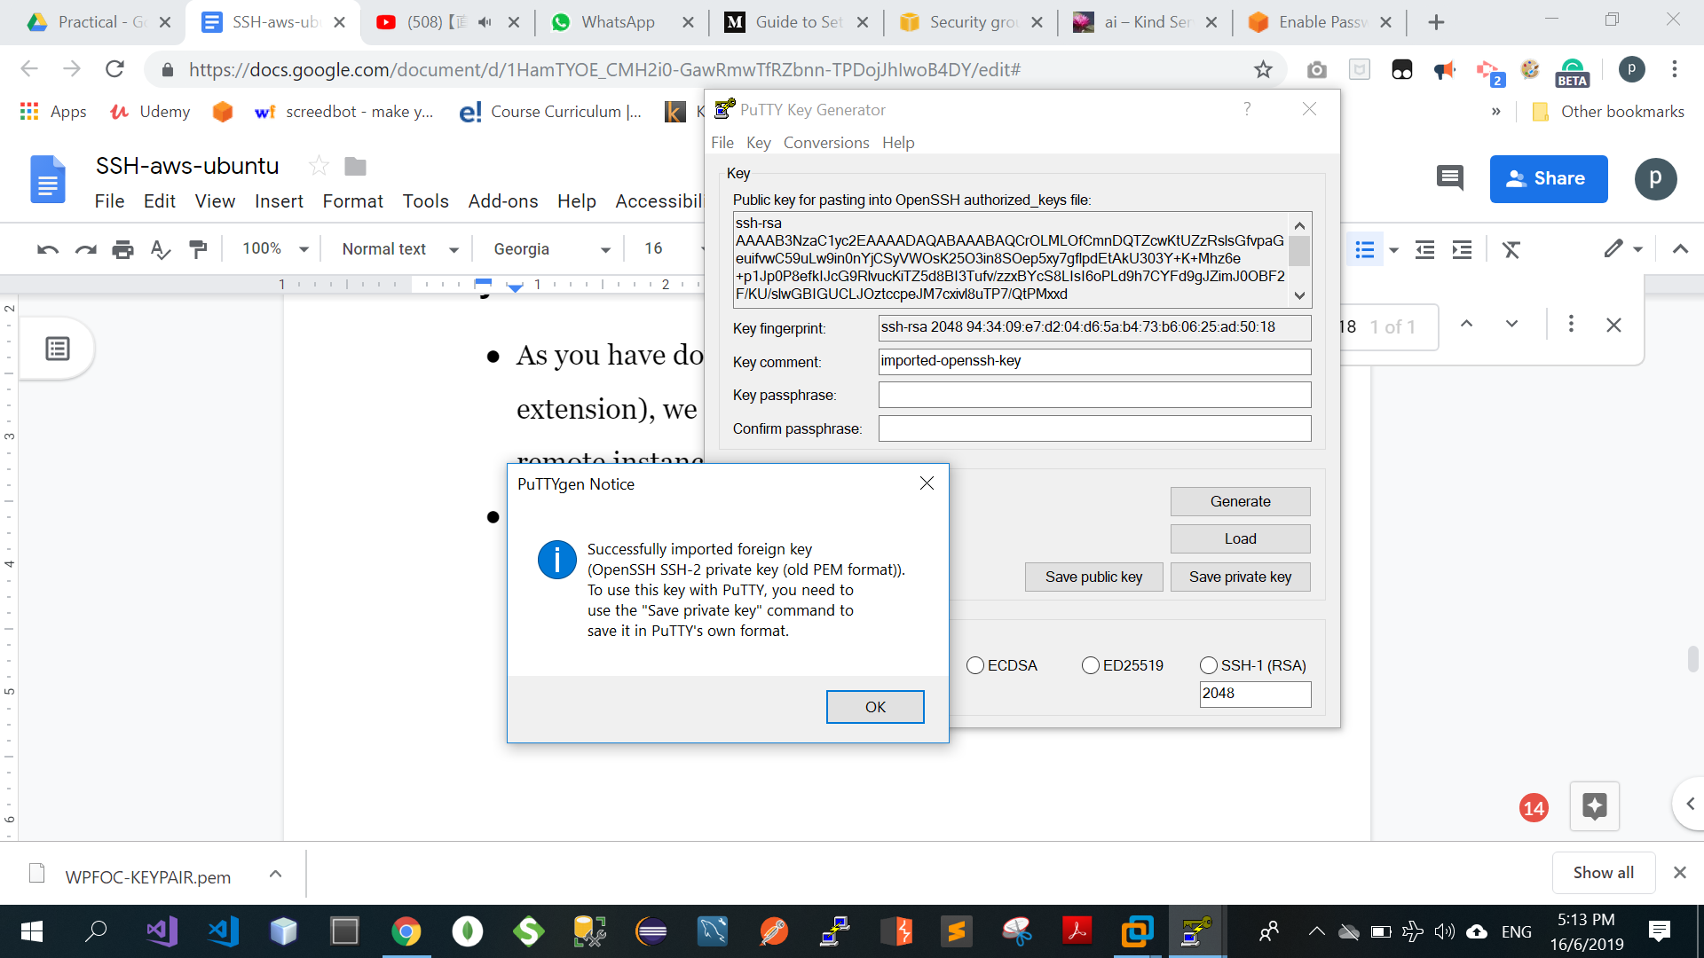
2. Open Putty, select **“Connection” -> “SSH” -> “Auth” -> “Browse…”** and load the WPFOC.ppk file.

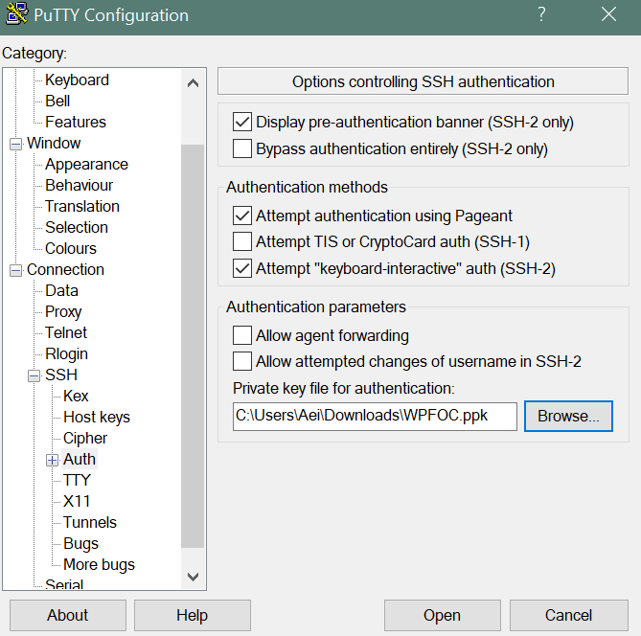

1. Select **“Session”** and fill the Host Name field with **<your public dns>.** You can also save the session by giving it a name under **“Saved Sessions”** and click on **“Save”** button.

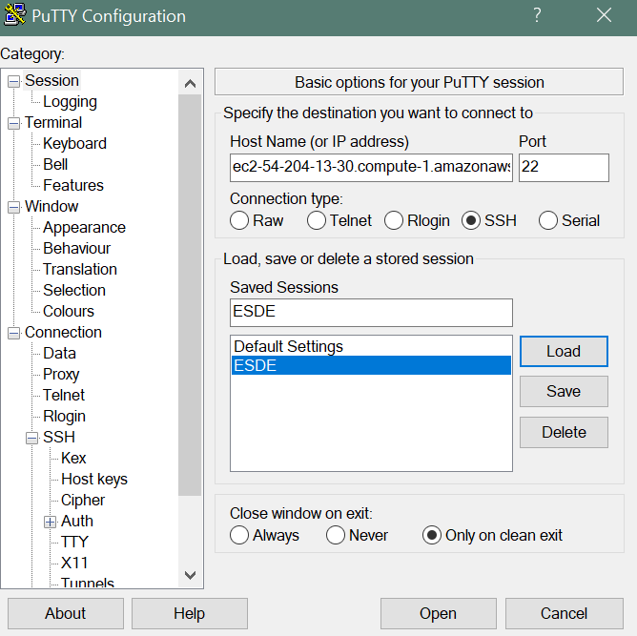

1. Click on **“Open”**, **“yes”** and login as **“ubuntu”** to the server.

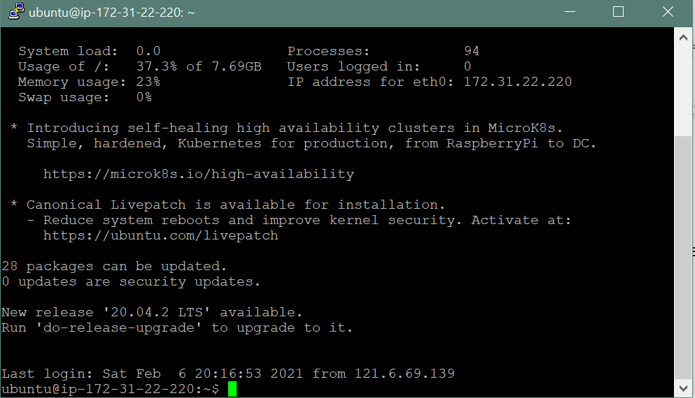

You are now logged in.

**2.0 Step 2: Developing with Amazon S3**

**2.1 Create a Bucket**

1. Under AWS Services, select **“S3”**

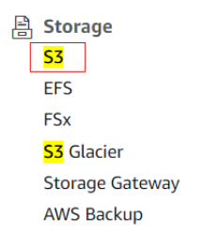

1. Click **“Create Bucket”**
2. Name the Bucket Name: **esdeaws** and Select Region to be **US East (N. Virginia) us-east-1**

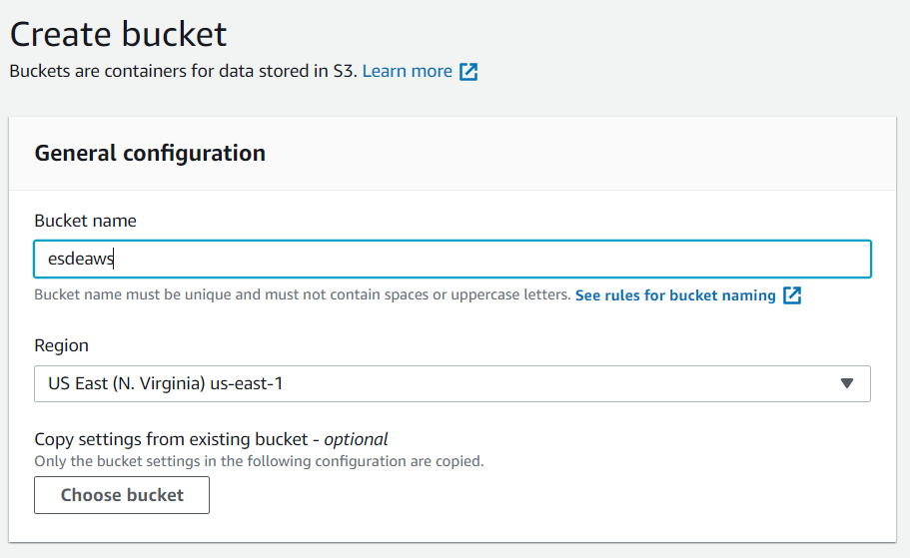

1. Keep others as default settings
2. Click **“Create Bucket”** button

**2.1.1 Install Node on EC2 Instance**

1. Install Node on the instance in your terminal or git bash: **curl -o- https://raw.githubusercontent.com/creationix/nvm/v0.33.11/install.sh | bash**

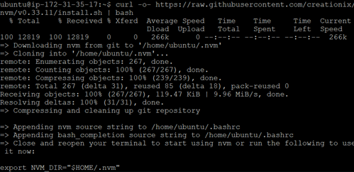

1. Close and reopen your terminal to start using nvm
2. Use nvm to install Node.js because nvm can install multiple versions of Node.js and allow you to switch between them: **. ~/.nvm/nvm.sh**



1. Installing the node version 8.10.: **nvm install 8.10**

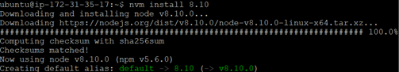

1. Check your node version: **node -v**



**2.1.2 Start Server to run forever**

1. **npm install -g pm2**



1. Go to the directory and run: **pm2 start server.js**

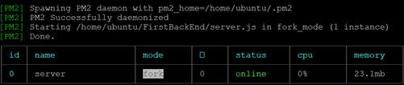

1. Open in browser: **http://[your public IP address or domain name]:8081**



(The image above shows the expected result.)

**2.2 Enable Static Website Hosting**

1. Click into your Bucket “esdeaws”
2. Select **“Properties”**



1. Under “Properties”, scroll down to find **“Static website hosting”** -> Click **“Edit”** button

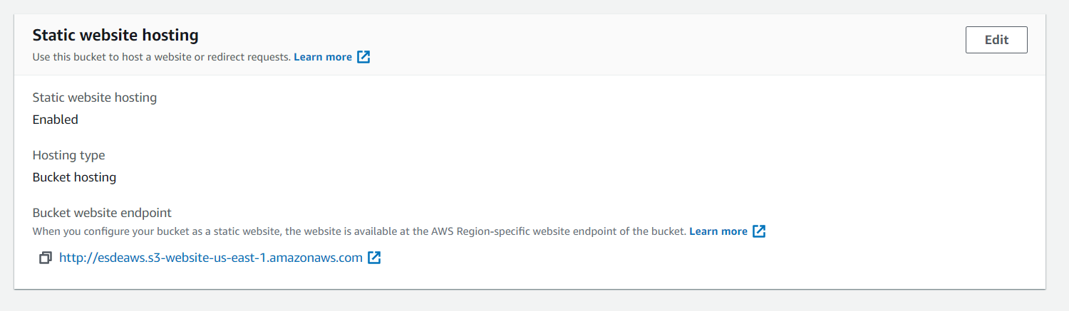

1. **“Enable”** the Static website hosting and key in **“home.html”** under the Index document.

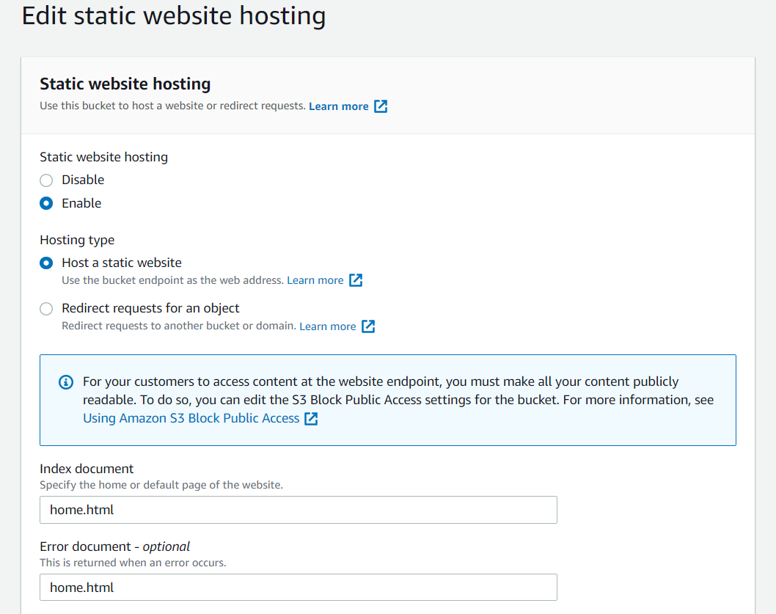

1. Click “Save Changes” button
2. Take note of the Bucket website endpoint: **http://esdeaws.s3-website-us-east-1.amazonaws.com**

**2.3 Add Bucket Policy**

1. Click into your Bucket “esdeaws”
2. Select **“Properties”**
3. Scroll down to find **“Bucket policy”** -> Click **“Edit”** button
4. Key in the follow code:

{

"Version": "2012-10-17",

"Statement": [

{

"Sid": "PublicReadGetObject",

"Effect": "Allow",

"Principal": "*",

"Action": "s3:GetObject",

"Resource": "arn:aws:s3:::esdeaws/*"

}

]

}

“Resource” is found under your “esdeaws” bucket -> “Properties” -> “Bucket overview” -> Amazon resource name (ARN)

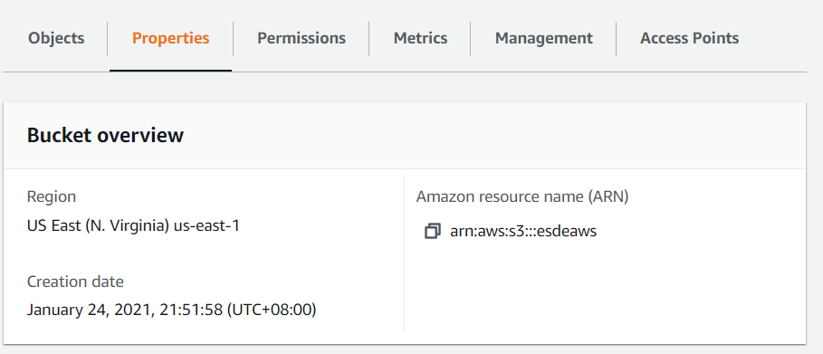

1. Click “Save changes” button

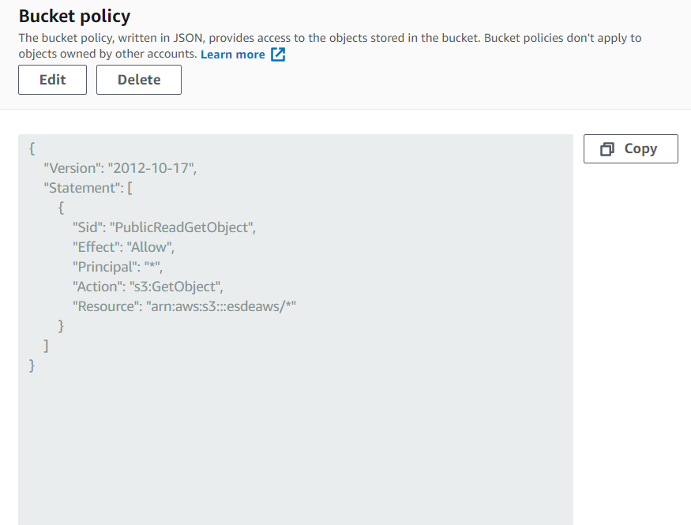

The image above shows how the Bucket policy should look like.

**2.4 Upload files**

1. Click into your Bucket “esdeaws”
2. Click “Upload” button and select the HTML files to be uploaded

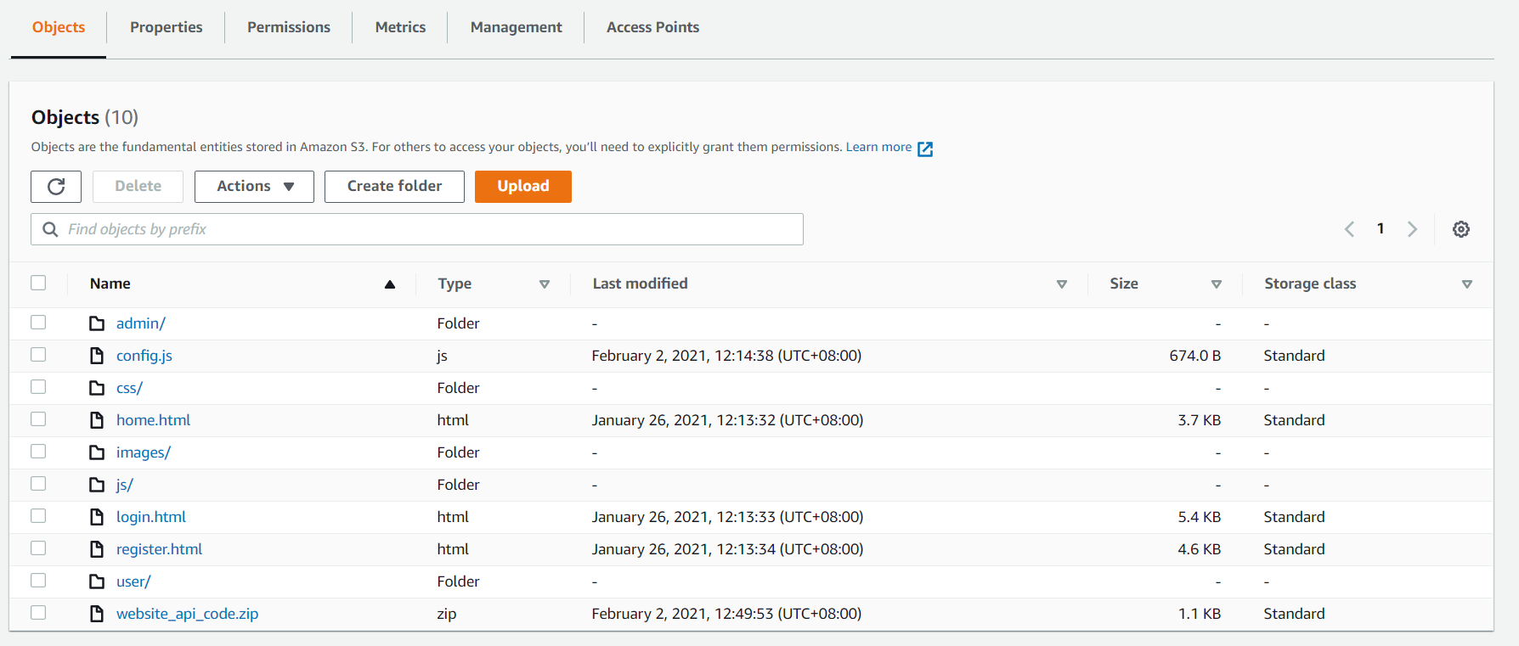

**2.5 Test Website Endpoint**

1. To test your website, enter the Bucket website endpoint that we noted down previously: **http://esdeaws.s3-website-us-east-1.amazonaws.com**

If the browser displays your .html page, the website has been deployed successfully.

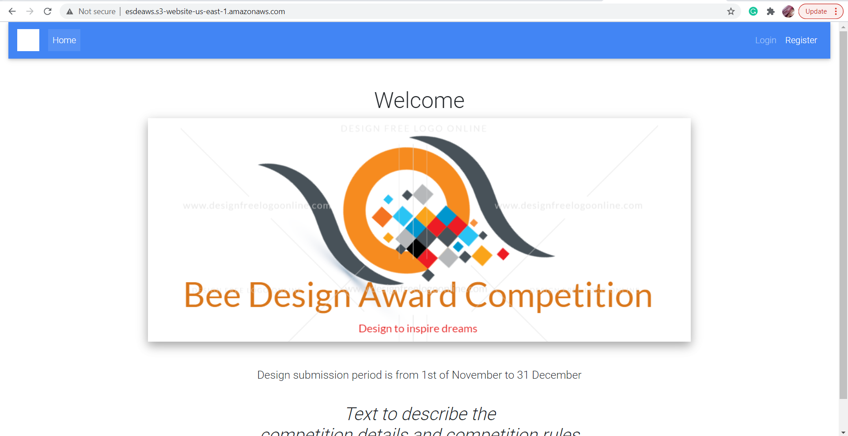

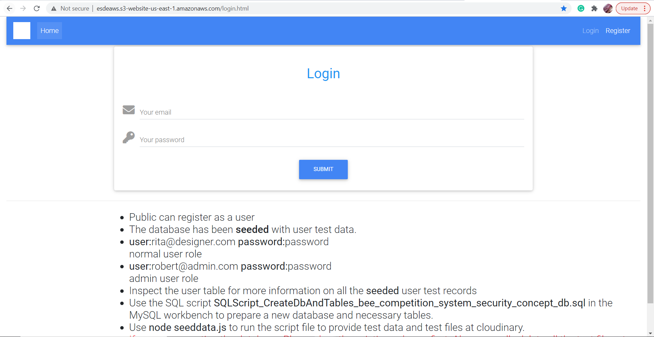

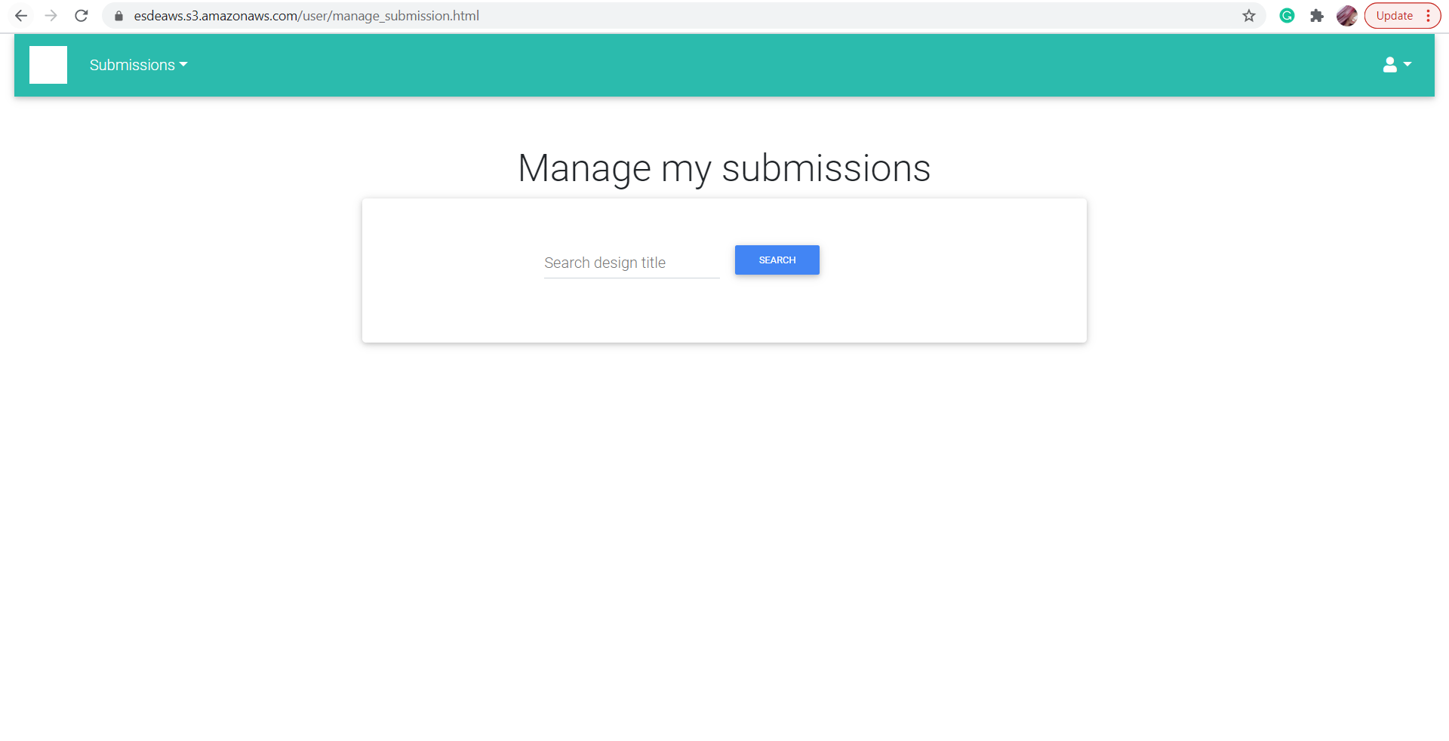

**3.0 Step 3: Create and Connect to a MySQL Database with Amazon RDS**

**3.1 Create a RDS instance**

1. Under AWS services, select **“RDS”**

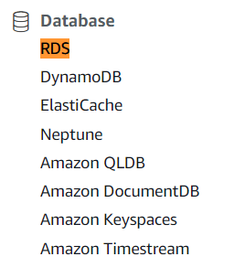

1. Click on “Create database” button
2. Keep everything as default, except for the following screenshots: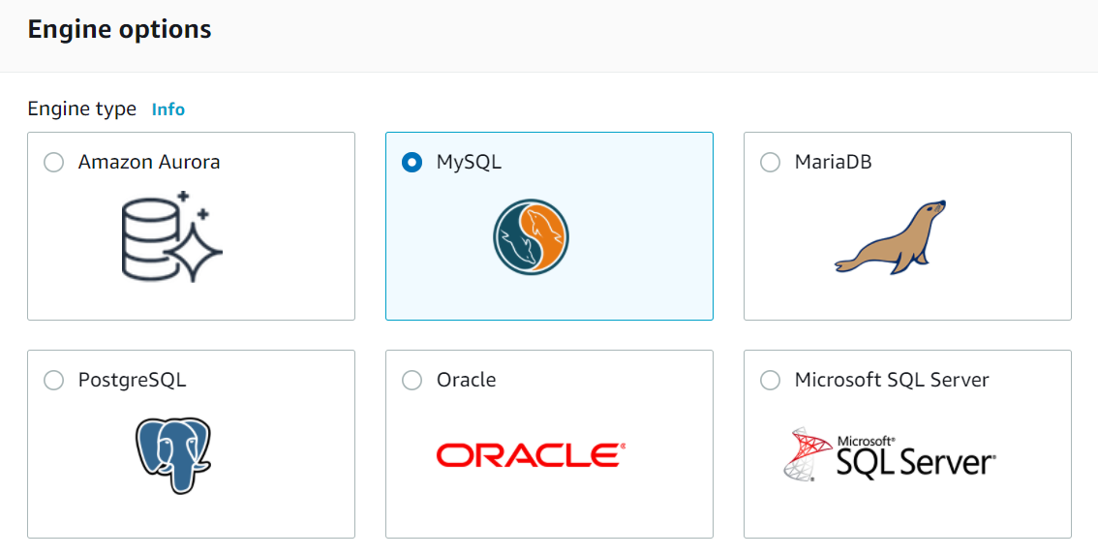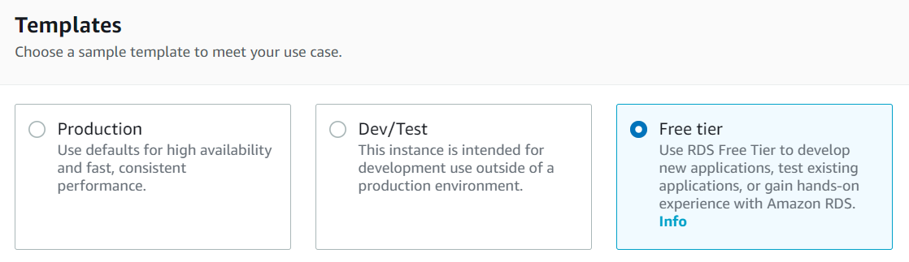

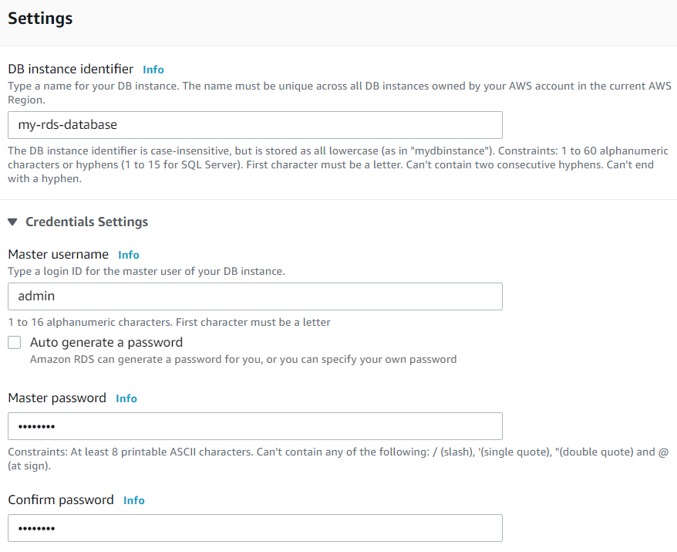

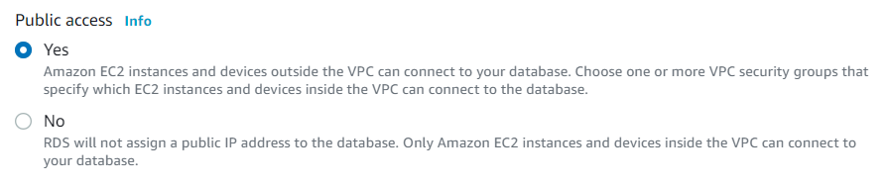

1. Click on **“Create database”** button, you should see your RDS instance being created:

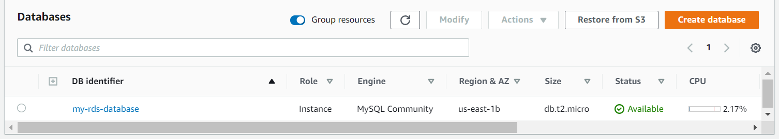

1. Click into your RDS instance and note down the endpoint and port number under “Connectivity & security”. You should see something like the following: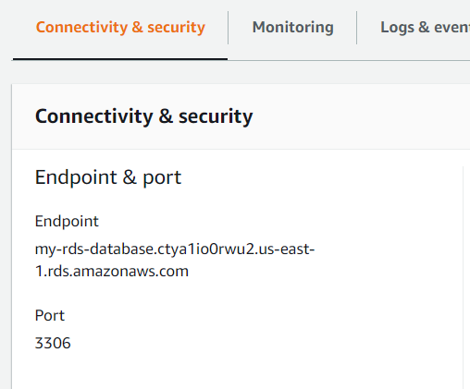

**3.2 Connect RDS instance with MySQL Workbench**

1. Launch MySQL Workbench and locate the + icon to add a new connection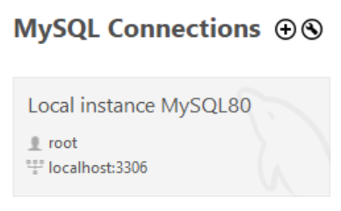
2. Fill in the Hostname, Port and Username that we have recorded down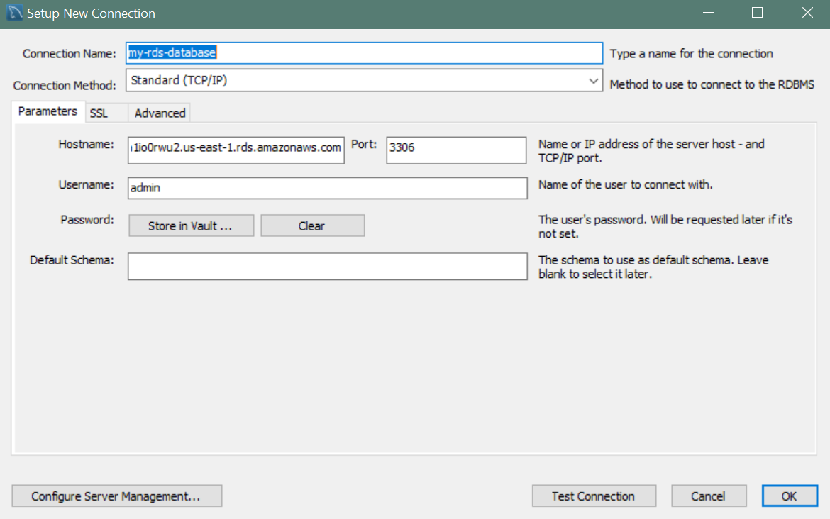
3. Click on “Test Connection” button, there should be a pop-up prompting for your RDS admin password you have created earlier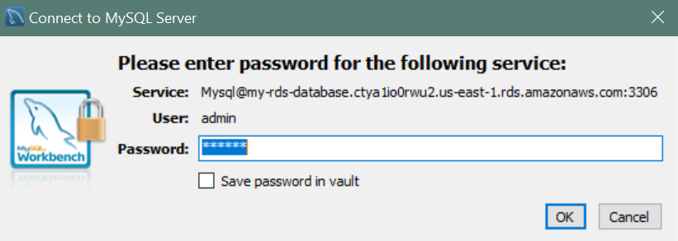
4. Key in your password and there should be a pop-up stating “Successfully made the MySQL connection”

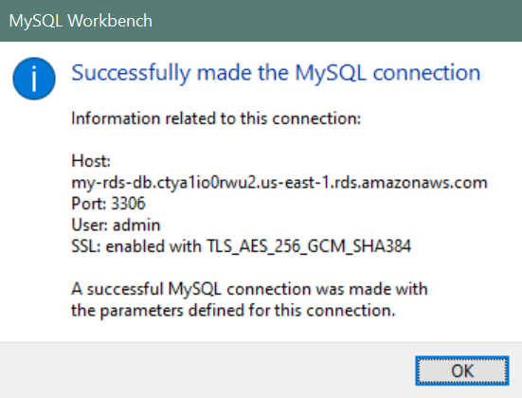

1. You should be able to see the new MySQL connection being created:

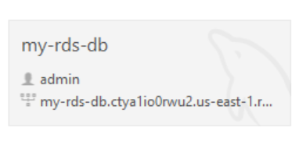

**3.3 Load SQL file into new connection to create database**

1. Open the SQL script file *SQLScript_CreateDbAndTables_bee_competition_system_security_concept_db.sql* and execute it.
2. You should be able to see the ‘file’, ‘role’ and ‘user’ tables being created in your MySQL Workbench.

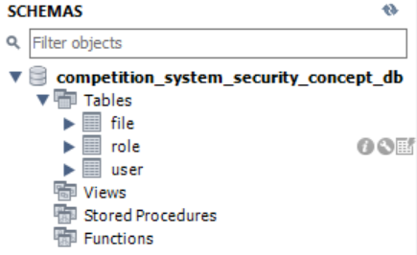

1. Create a SQL dump file to insert data into the current database
2. Your tables should now have relevant data inside:
   1. File

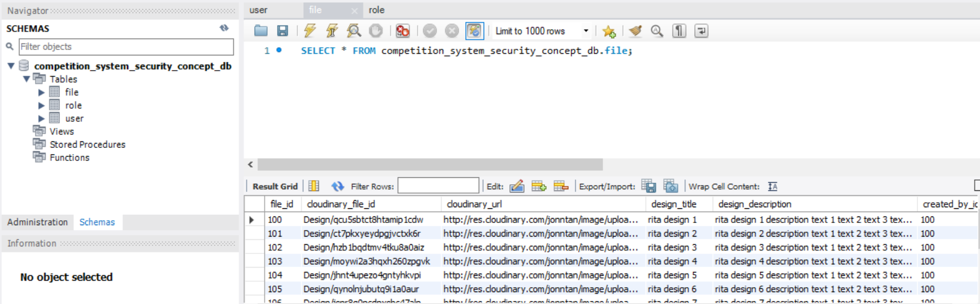

* 1. User

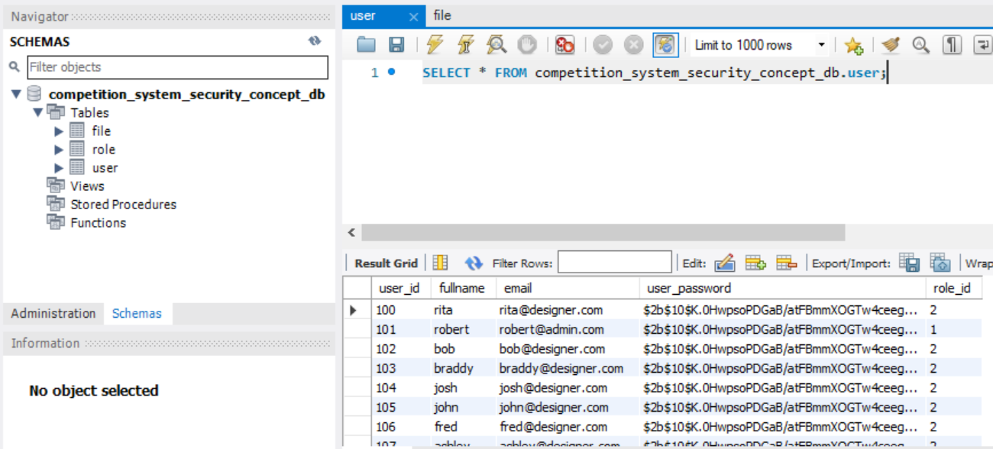

* 1. Role

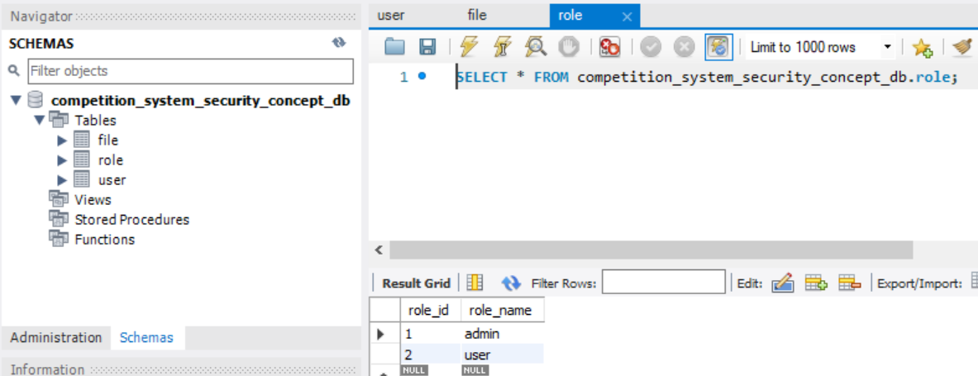

**3.4 Configure database connection in EC2**

1. Open the *database.js* in Visual Studio Code
2. Edit the following:

* Change host to the endpoint of the RDS
* Change user to the username set in RDS
* Change password to password set in RDS
* Change database name to the database name in MySQL

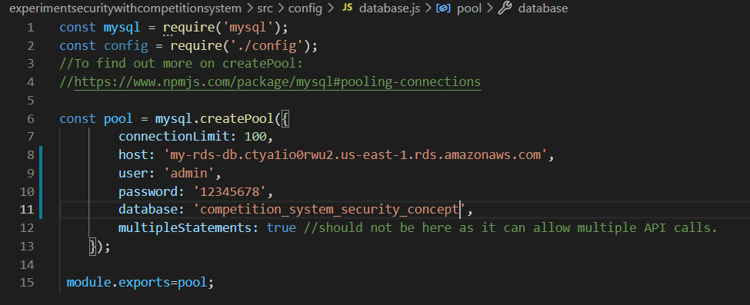

**3.5 POSTMAN Testing**

1. Launch POSTMAN
2. Select “GET” request and enter:

http://**[your domain name]**/api/user/process-search-design/1/

1. You should be able to GET the data from your database:

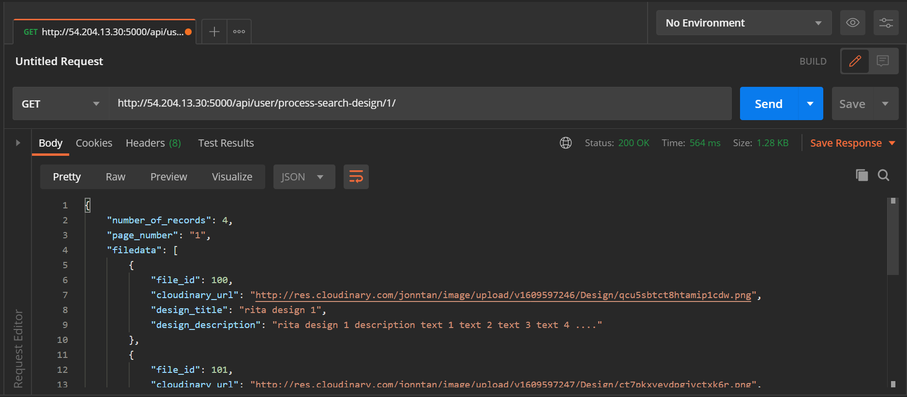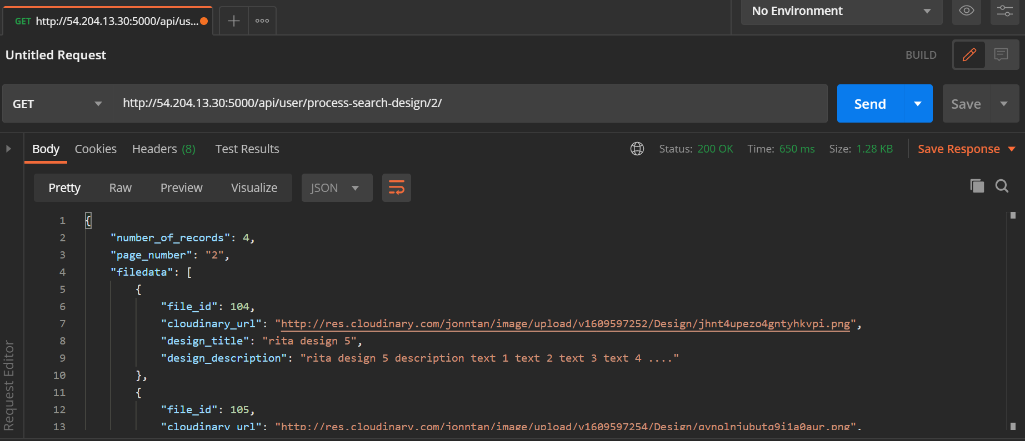

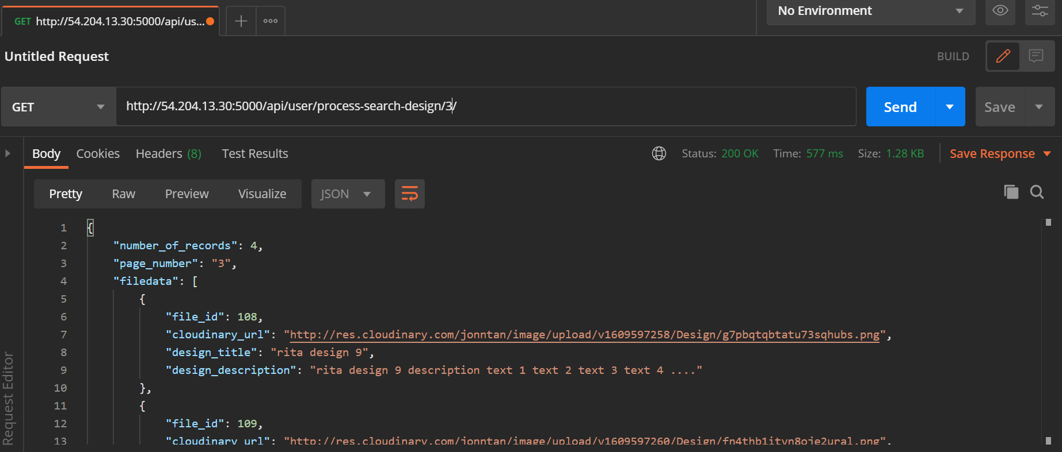

Due to pagination, all data can only be shown over the course of 3 pages.

**3.5.1 Code Snippets: Axios Call for API Gateway**

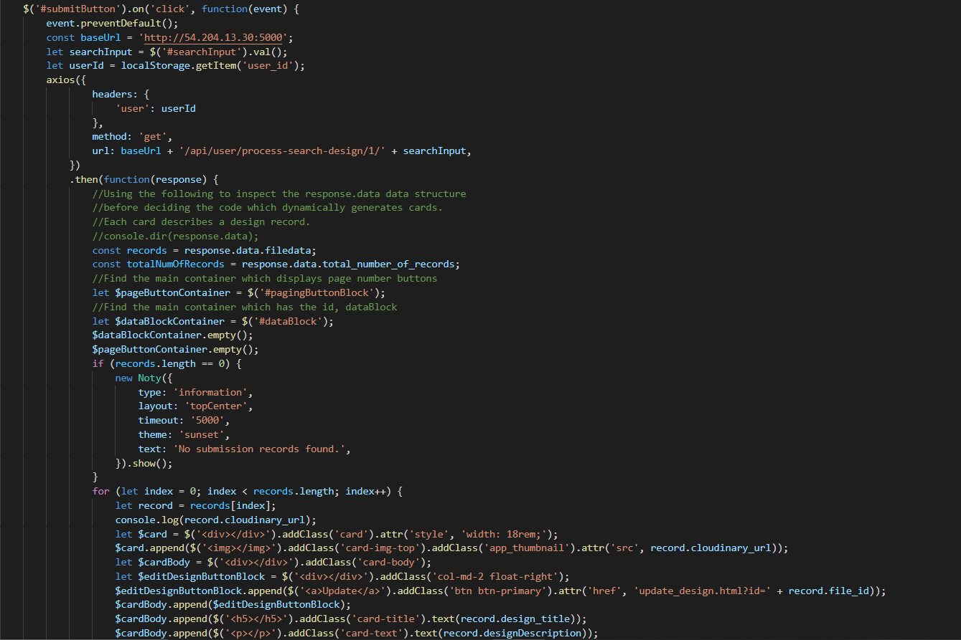

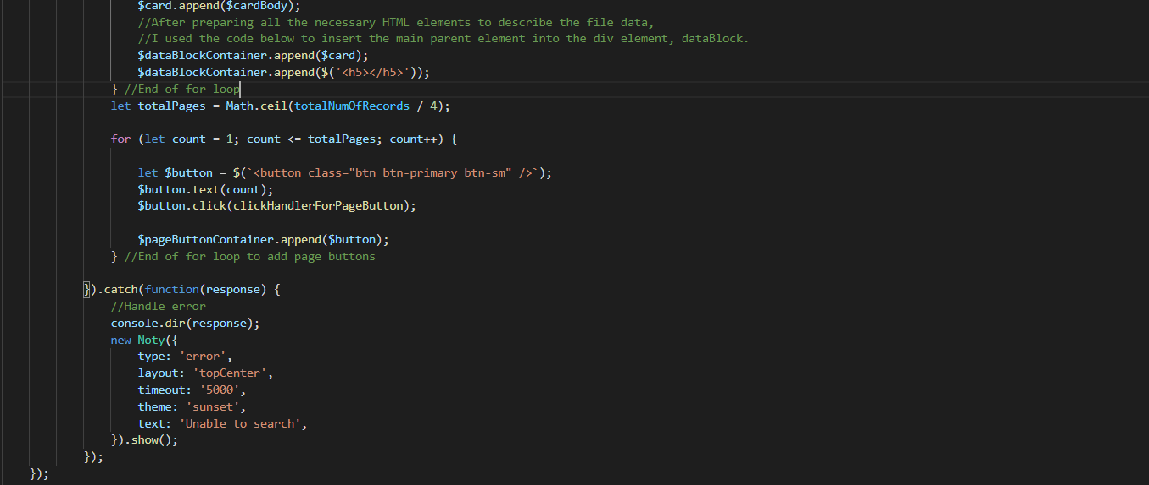

**4.0 Step 4: Developing with Amazon DynamoDB using AWS SDK**

**4.1 Create Cloud9 Environment**

1. Under AWS services, select **“Cloud9”**

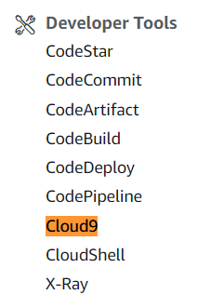

1. Click on “Create environment” button

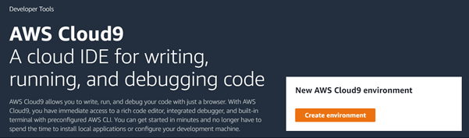

1. Key in a name for the environment -> Click “Next step” button

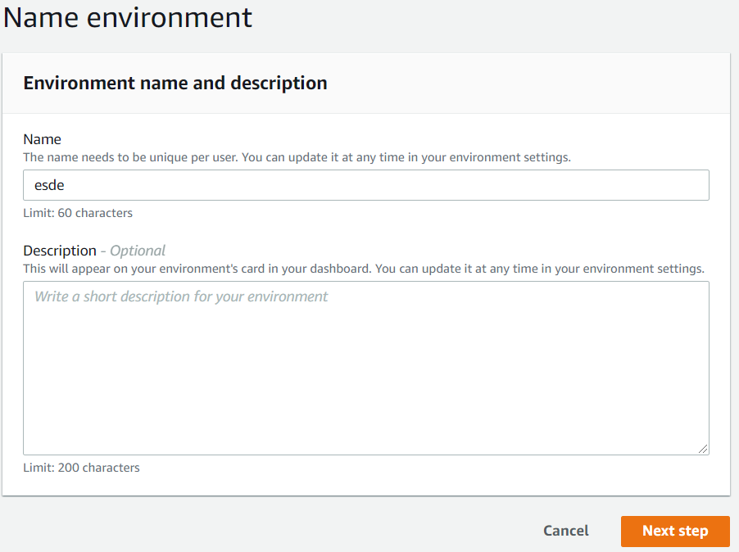

1. Under “Platform”, select **“Ubuntu Server 18.04 LTS”** -> Click “Next step” button

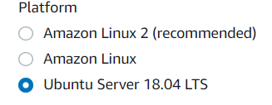

1. Click “Create environment”

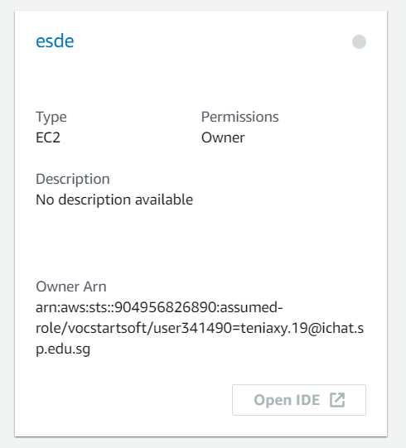

(You wil be able to see the above Cloud9 environment)

1. You should be able brought into the Cloud9 IDE that looks like this:

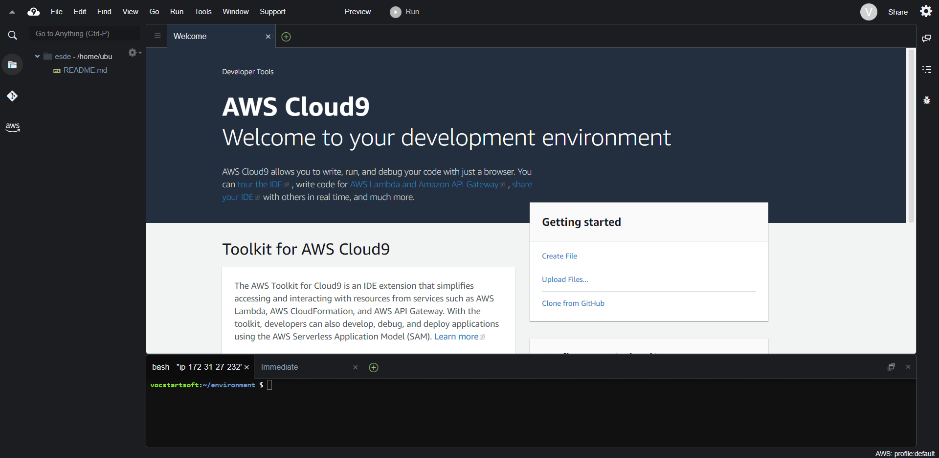

1. To seed the AWS Cloud9 files, go to the AWS Cloud9 base terminal (at the bottom of the page) and run the follow wget command:

**wget https://aws-tc-largeobjects.s3-us-west-2.amazonaws.com/DEV-ILT-TF-200-ACCDEV-1/lab-3-ddb.zip -P /home/ubuntu/environment**

1. To unzip the lab-3-ddb.zip file, run the follow command:

**unzip lab-3-ddb.zip**

1. To clean your environment, remove the .zip, README.md, python_3.6.8 and ruby_2.6.0 folders.
2. Move the .js files from the solution folder (found under node_8.10.0 folder) into the node_8.10.0 folder and overwrite the current .js files. Your folder should look like this:

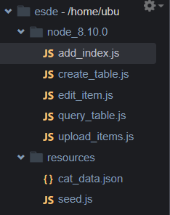

1. Set the correct terminal path: **cd node_8.10.0**
2. Initialize the code environment (One-Time Initialization and Import): **npm install aws-sdk**

**4.2 Create DynamoDB Table**

1. In the code folder, double-click the create_table file to open it.
2. Change the codes accordingly:

var

AWS = require("aws-sdk"),

DDB = new AWS.DynamoDB({

apiVersion: "2012-08-10",

region: "us-east-1"

});

(function createADataBaseTable(){

var

params = {

AttributeDefinitions: [{

AttributeName: "file_id",

AttributeType: "N"

}],

KeySchema: [{

AttributeName: "file_id",

KeyType: "HASH"

}],

ProvisionedThroughput: {

ReadCapacityUnits: 1,

WriteCapacityUnits: 1

},

TableName: "file",

};

DDB.createTable(params, function(err, data){

console.log(err, data);

});

})();

1. Run **node create_table.js**

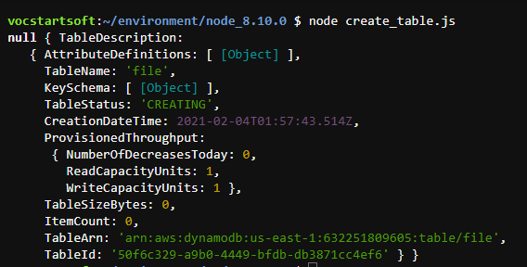

1. Under AWS services, select **“DynamoDB”** and you should be able to see a table ‘file’ being created.

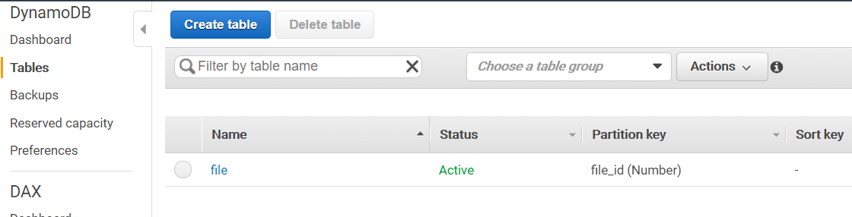

1. Repeat steps 2 and 3 to create the ‘user’ and ‘role’ table as well.

Note: Change the AttributeName, AttributeType and TableName accordingly.

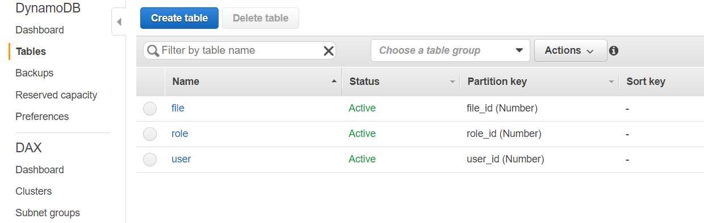

This is the expected result in DynamoDB.

**4.3 Upload / Add Items to a DynamoDB Table**

1. In the code folder, double-click the upload_items file to open it.
2. Change the codes accordingly:

var

AWS = require("aws-sdk"),

DDB = new AWS.DynamoDB({

apiVersion: "2012-08-10",

region: "us-east-1"

});

(function uploadItemstoDynamoDB(){

var

file1 = {

Item:{

"file_id":{

N: "100"

},

"cloudinary_file_id":{

S: "Design/qcu5sbtct8htamip1cdw"

},

"cloudinary_url":{

S: "http://res.cloudinary.com/jonntan/image/upload/v1609597246/Design/qcu5sbtct8htamip1cdw.png"

},

"design_title":{

S: "rita design 1"

},

"design_description":{

S: "rita design 1 description text 1 text 2 text 3 text 4 ...."

},

"created_by_id":{

N: "100"

}

},

ReturnConsumedCapacity: "TOTAL",

TableName: "file"

};

DDB.putItem(file1, function(err, data){

console.log(err, data);

});

})();

1. Run **node upload_items.js**



1. You should be able to see the item being uploaded in the ‘file’ table.

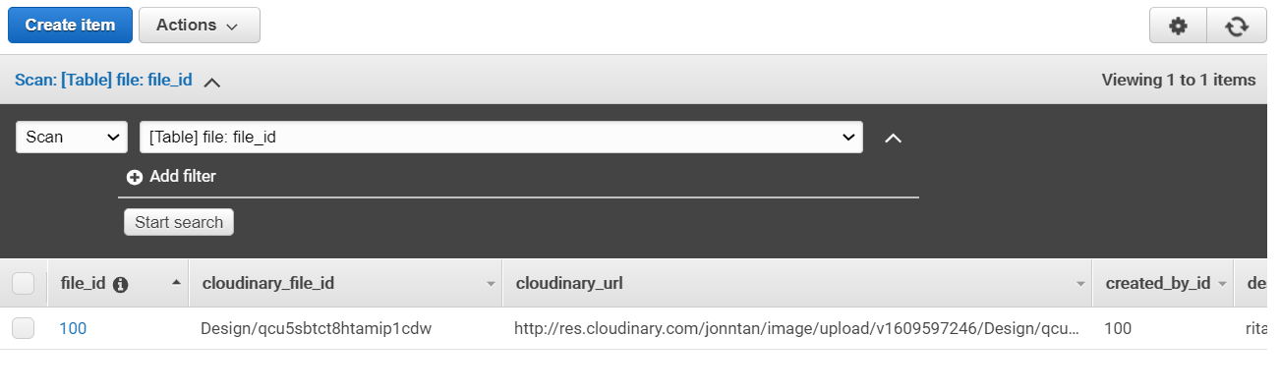

1. Repeat steps 2 and 3 to create an item in the ‘user’ and ‘role’ table.

Note: Change the AttributeName, AttributeType, data and TableName accordingly.

**4.4 Populate Database**

1. In the AWS Cloud9 filesystem, identify the folder called *resources*. The folder contains 2 files: *cat_data.json* and *seed.js*.
2. In the AWS Cloud9 terminal, navigate to the *resources* folder by running the following command:  **cd ~/environment/resources**
3. Run the following command: **npm install aws-sdk**
4. Change the codes in *seed.js* accordingly:

var

AWS = require("aws-sdk"),

DDB = new AWS.DynamoDB({

apiVersion: "2012-08-10",

region: "us-east-1"

}),

CAT_DATA_ARR = require("./cat_data.json");

function addNewItemsFromJSON(){

console.log("All items now removed, re-seeding now");

var

cat = {},

cat_formatted_arr = [],

params = {};

for(var i_int = 0; i_int < CAT_DATA_ARR.length; i_int += 1){

cat = {

PutRequest: {

Item: {

file_id: {

"N": CAT_DATA_ARR[i_int].file_id

},

cloudinary_file_id: {

"S": CAT_DATA_ARR[i_int].cloudinary_file_id

},

cloudinary_url: {

"S": CAT_DATA_ARR[i_int].cloudinary_url

},

design_title: {

"S": CAT_DATA_ARR[i_int].design_title

},

design_description: {

"S": CAT_DATA_ARR[i_int].design_description

},

created_by_id: {

"N": CAT_DATA_ARR[i_int].created_by_id

}

}

}

};

cat_formatted_arr.push(cat);

}

params = {

RequestItems: {

"file": cat_formatted_arr.reverse()

}

};

DDB.batchWriteItem(params, function(err, data){

if(err){

throw err;

}

console.log("OK");

});

}

function init(){

addNewItemsFromJSON();

}

init();

1. Change the codes in *cat_data.json* accordingly:

[{

"file_id": "100",

"cloudinary_file_id": "Design/qcu5sbtct8htamip1cdw",

"cloudinary_url": "http://res.cloudinary.com/jonntan/image/upload/v1609597246/Design/qcu5sbtct8htamip1cdw.png",

"design_title": "rita design 1",

"design_description": "rita design 1 description text 1 text 2 text 3 text 4 ....",

"created_by_id": "100"

},

{

"file_id": "101",

"cloudinary_file_id": "Design/ct7pkxyeydpgjvctxk6r",

"cloudinary_url": "http://res.cloudinary.com/jonntan/image/upload/v1609597247/Design/ct7pkxyeydpgjvctxk6r.png",

"design_title": "rita design 2",

"design_description": "rita design 2 description text 1 text 2 text 3 text 4 ....",

"created_by_id": "100"

},

{

"file_id": "102",

"cloudinary_file_id": "Design/hzb1bqdtmv4tku8a0aiz",

"cloudinary_url": "http://res.cloudinary.com/jonntan/image/upload/v1609597249/Design/hzb1bqdtmv4tku8a0aiz.png",

"design_title": "rita design 3",

"design_description": "rita design 3 description text 1 text 2 text 3 text 4 ....",

"created_by_id": "100"

},

{

"file_id": "103",

"cloudinary_file_id": "Design/moywi2a3hqxh260zpgvk",

"cloudinary_url": "http://res.cloudinary.com/jonntan/image/upload/v1609597251/Design/moywi2a3hqxh260zpgvk.png",

"design_title": "rita design 4",

"design_description": "rita design 4 description text 1 text 2 text 3 text 4 ....",

"created_by_id": "100"

},

{

"file_id": "104",

"cloudinary_file_id": "Design/jhnt4upezo4gntyhkvpi",

"cloudinary_url": "http://res.cloudinary.com/jonntan/image/upload/v1609597252/Design/jhnt4upezo4gntyhkvpi.png",

"design_title": "rita design 5",

"design_description": "rita design 5 description text 1 text 2 text 3 text 4 ....",

"created_by_id": "100"

},

{

"file_id": "105",

"cloudinary_file_id": "Design/qynolnjubutq9i1a0aur",

"cloudinary_url": "http://res.cloudinary.com/jonntan/image/upload/v1609597254/Design/qynolnjubutq9i1a0aur.png",

"design_title": "rita design 6",

"design_description": "rita design 6 description text 1 text 2 text 3 text 4 ....",

"created_by_id": "100"

},

{

"file_id": "106",

"cloudinary_file_id": "Design/jsnr8g0pcdpxshc47alp",

"cloudinary_url": "http://res.cloudinary.com/jonntan/image/upload/v1609597255/Design/jsnr8g0pcdpxshc47alp.png",

"design_title": "rita design 7",

"design_description": "rita design 7 description text 1 text 2 text 3 text 4 ....",

"created_by_id": "100"

},

{

"file_id": "107",

"cloudinary_file_id": "Design/gbnpxpcqoj6tv9vjzgig",

"cloudinary_url": "http://res.cloudinary.com/jonntan/image/upload/v1609597257/Design/gbnpxpcqoj6tv9vjzgig.png",

"design_title": "rita design 8",

"design_description": "rita design 8 description text 1 text 2 text 3 text 4 ....",

"created_by_id": "100"

},

{

"file_id": "108",

"cloudinary_file_id": "Design/g7pbqtqbtatu73sqhubs",

"cloudinary_url": "http://res.cloudinary.com/jonntan/image/upload/v1609597258/Design/g7pbqtqbtatu73sqhubs.png",

"design_title": "rita design 9",

"design_description": "rita design 9 description text 1 text 2 text 3 text 4 ....",

"created_by_id": "100"

},

{

"file_id": "109",

"cloudinary_file_id": "Design/fn4thb1itvn8oje2ural",

"cloudinary_url": "http://res.cloudinary.com/jonntan/image/upload/v1609597260/Design/fn4thb1itvn8oje2ural.png",

"design_title": "rita design 10",

"design_description": "rita design 10 description text 1 text 2 text 3 text 4 ....",

"created_by_id": "100"

},

{

"file_id": "110",

"cloudinary_file_id": "Design/ztxlrezlx3okr4dargtk",

"cloudinary_url": "http://res.cloudinary.com/jonntan/image/upload/v1609597262/Design/ztxlrezlx3okr4dargtk.png",

"design_title": "rita design 11",

"design_description": "rita design 11 description text 1 text 2 text 3 text 4 ....",

"created_by_id": "100"

},

{

"file_id": "111",

"cloudinary_file_id": "Design/x35fi9d0tntzwer70c1k",

"cloudinary_url": "http://res.cloudinary.com/jonntan/image/upload/v1609597263/Design/x35fi9d0tntzwer70c1k.png",

"design_title": "rita design 12",

"design_description": "rita design 12 description text 1 text 2 text 3 text 4 ....",

"created_by_id": "100"

}]

1. Run **node seed.js**

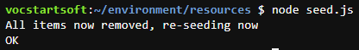

1. You should see the items being seeded into the ‘file’ table

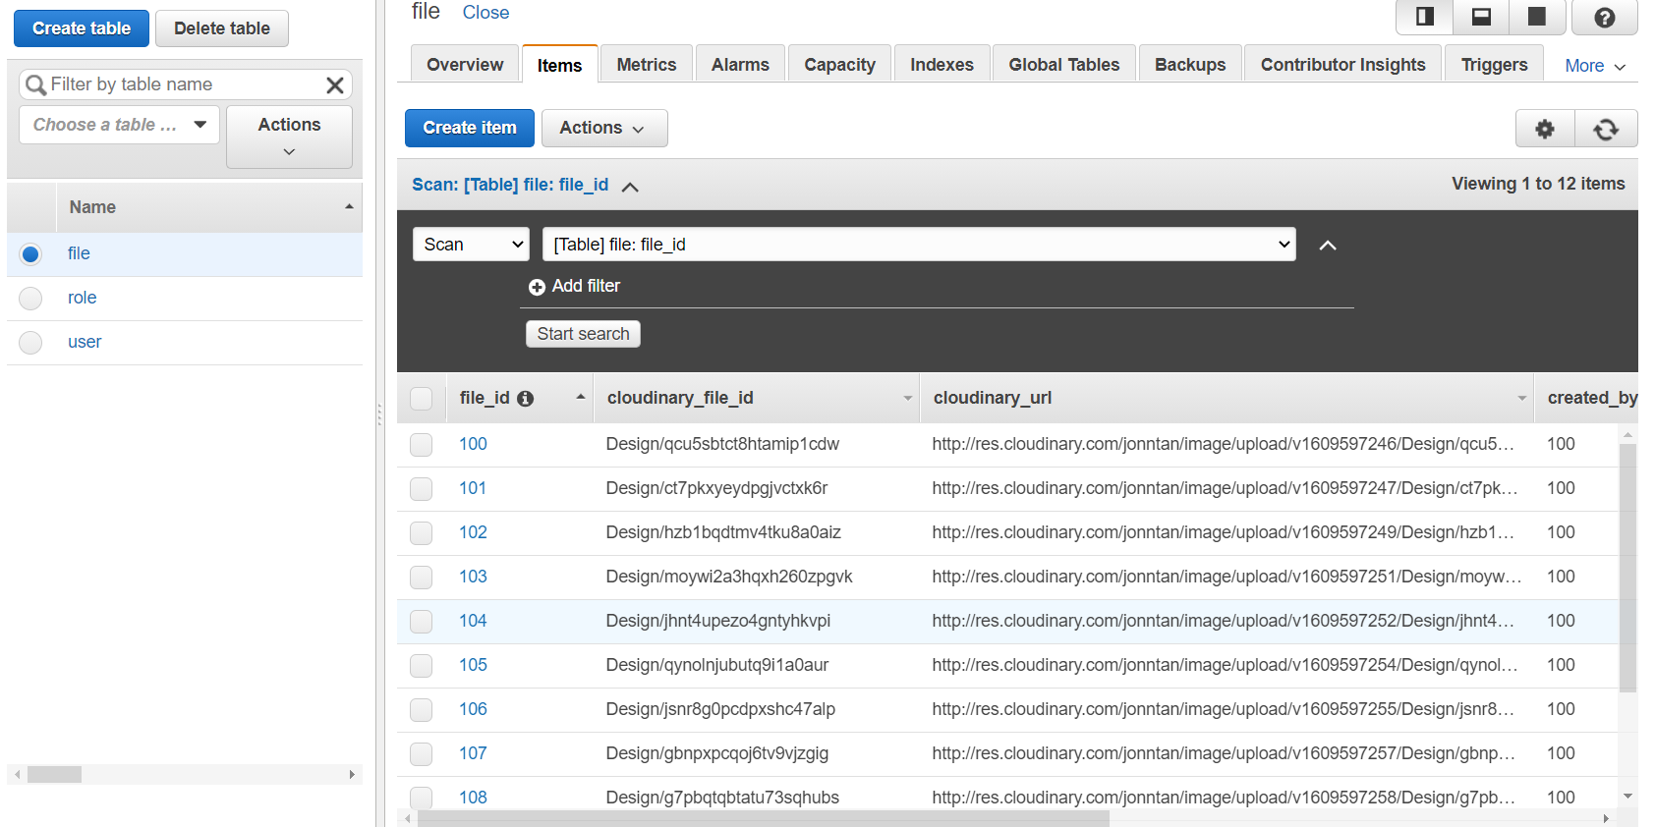

1. Repeat steps 4 and 5 to seed the data for ‘user’ and ‘role’ table.

Note: Change the data in *cat_data.json* and the AttributeName, AttributeType, data and TableName in *seed.js* accordingly.

**4.5 Query for Item in DynamoDB Table**

1. Navigate back to node_8.10.0 folder with the following command: **cd ~/environment/node_8.10.0**
2. In the code folder, double-click the query_table file to open it.
3. Change the code accordingly:

var

AWS = require("aws-sdk"),

DDB = new AWS.DynamoDB({

apiVersion: "2012-08-10",

region: "us-east-1"

});

(function queryTable(){

var

params = {

ExpressionAttributeValues: {

":file_id": {

N: "100"

}

},

KeyConditionExpression: "file_id = :file_id",

ProjectionExpression: "design_title",

TableName: "file"

};

DDB.query(params, function(err, data){

if(err){

throw err;

}

console.log(data.Items[0].design_title.S);

});

})();

1. Run **node query_table.js**



**4.6 Create GSI for DynamoDB Table**

1. In the code folder, double-click the add_index file to open it.
2. Change the code accordingly:

var

AWS = require("aws-sdk"),

DDB = new AWS.DynamoDB({

apiVersion: "2012-08-10",

region: "us-east-1"

});

(function addIndex(){

var

params = {

TableName: "file",

AttributeDefinitions: [{

AttributeName: "file_id",

AttributeType: "N"

}],

GlobalSecondaryIndexUpdates: [{

Create: {

IndexName: "file_id",

KeySchema: [{

AttributeName: "file_id",

KeyType: "HASH"

}],

Projection: {

ProjectionType: "ALL"

},

ProvisionedThroughput: {

ReadCapacityUnits: 1,

WriteCapacityUnits: 1

}

}

}]

};

DDB.updateTable(params, function(err, data){

console.log(err, data);

});

})();

1. Run **node add_index.js**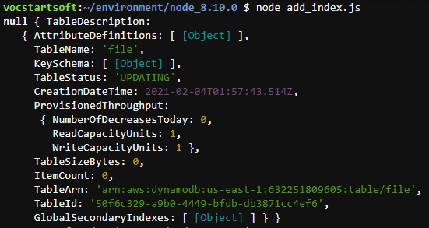
2. You should be able to search for a query based on the file_id:

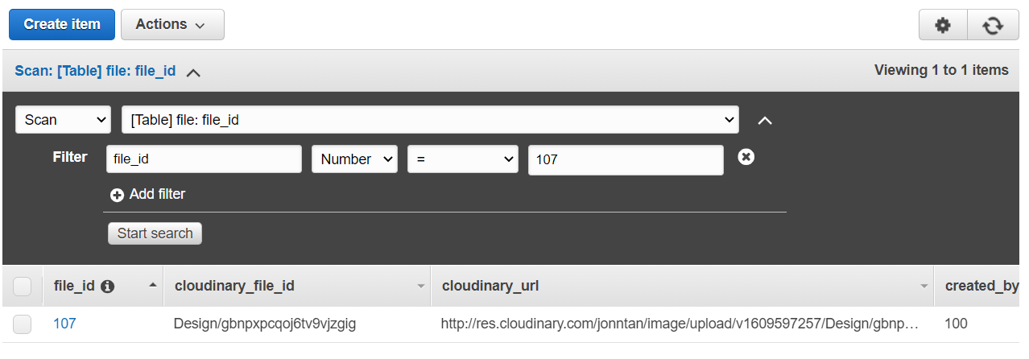

**5.0 Step 5: Developing with AWS Lambda and Amazon API Gateway**

**5.1 Create Cloud9 Environment**

1. Create a new Cloud9 Environment called “esde_lambda” (Refer to 4.1 steps 1-6)
2. To seed the AWS Cloud9 filesystem, go to the AWS Cloud9 bash terminal (at the bottom of the page) and run the following wget command:

**wget https://aws-tc-largeobjects.s3-us-west-2.amazonaws.com/DEV-ILT-TF-200-ACCDEV-1/lab-5-lambda-gateway.zip -P /home/ubuntu/environment**

1. To unzip the lab-5-lambda-gateway.zip file, run the following command:

**unzip lab-5-lambda-gateway.zip**

1. To clean your environment, remove the .zip, README.md, python_3.6.8 and ruby_2.6.0 folders.
2. Move the .js files from the solution folder (found under node_8.10.0 folder) into the node_8.10.0 folder and overwrite the current .js files. Your folder should look like this:

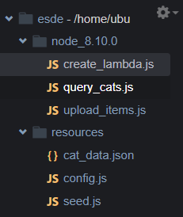

1. Set the correct terminal path: **cd node_8.10.0**
2. Initialize the code environment (One-Time Initialization and Import): **npm install aws-sdk**

**5.2 Create REST Endpoint with Amazon API Gateway**

1. Under AWS services, select “API Gateway”
2. Click “Get Started” button
3. Under “Choose an API type”, scroll down to the **REST API** section

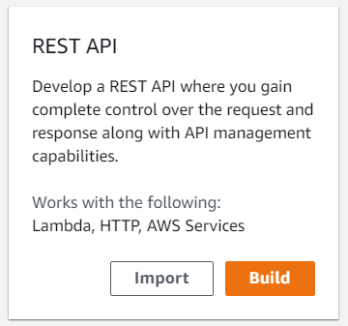

1. Click “Build” button
2. In the “Create your first API window”, click “OK” button
3. Under “Create new API”, select “New API”
4. Change the settings accordingly:

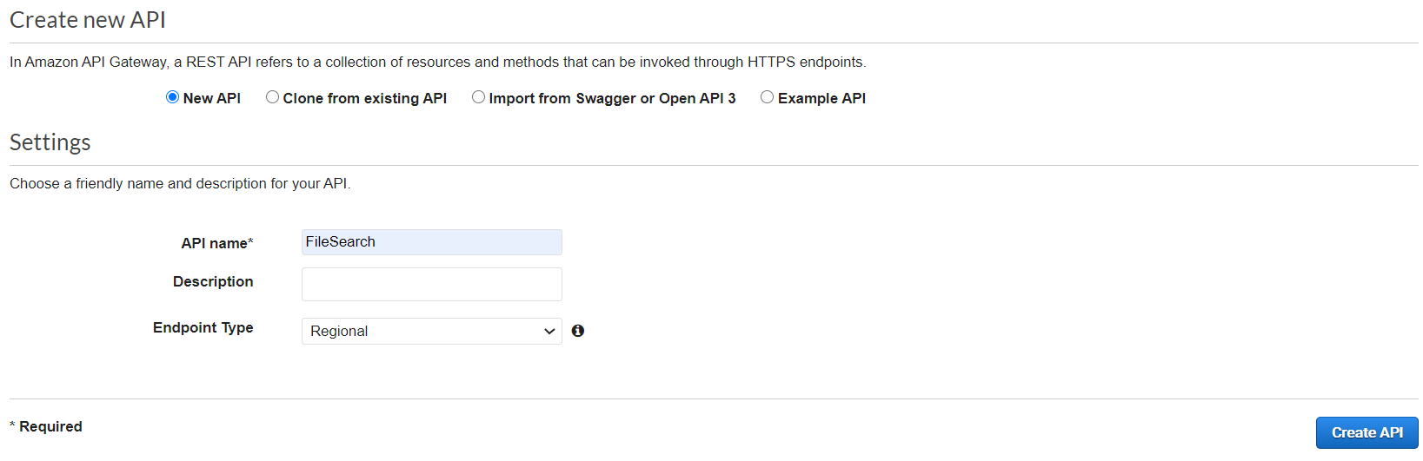

1. Click “Create API” button. You can now see that *FileSearch* API has been created: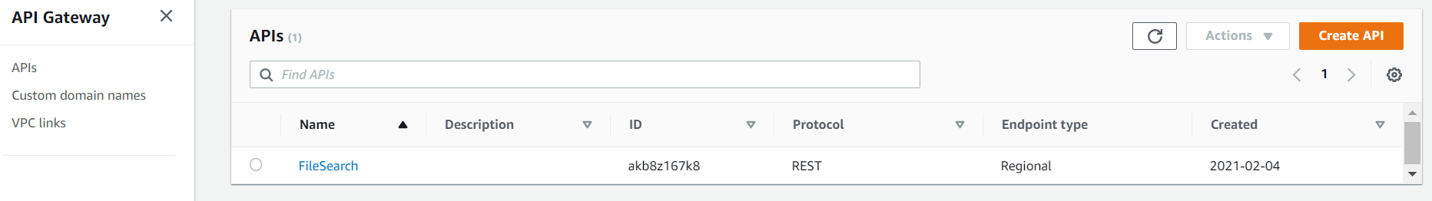
2. Within the API, choose “Actions” and then “Create Method”

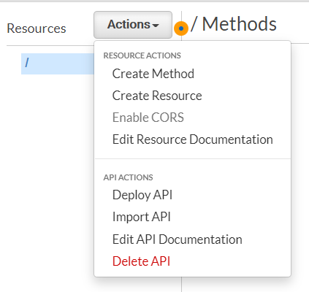

1. Under “Resources”, click on the dropdown bar under the ‘/’, choose POST, and choose the check mark icon.

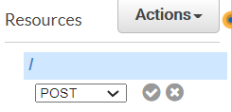

1. Under “Integration type”, choose “Mock” and then click “Save”

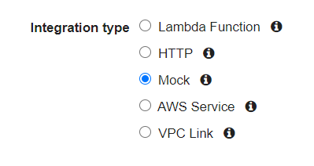

1. Click “TEST”
2. Scroll down. Under “Request Body”, enter the following JSON:

{

“file_id”: 100

}

1. Click “Test” button. You should see the following information: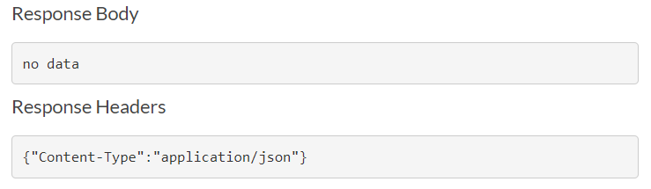

Logs should look similar to:

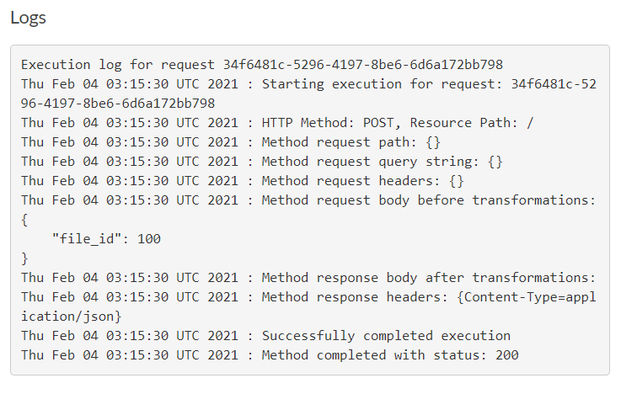

1. To go back to the test settings, scroll up and click “Method Execution”
2. Choose “Integration Response”
3. Click on dropdown arrow followed by the arrow for “Mapping Templates”
4. Under “Content-Type”, select **application/json**

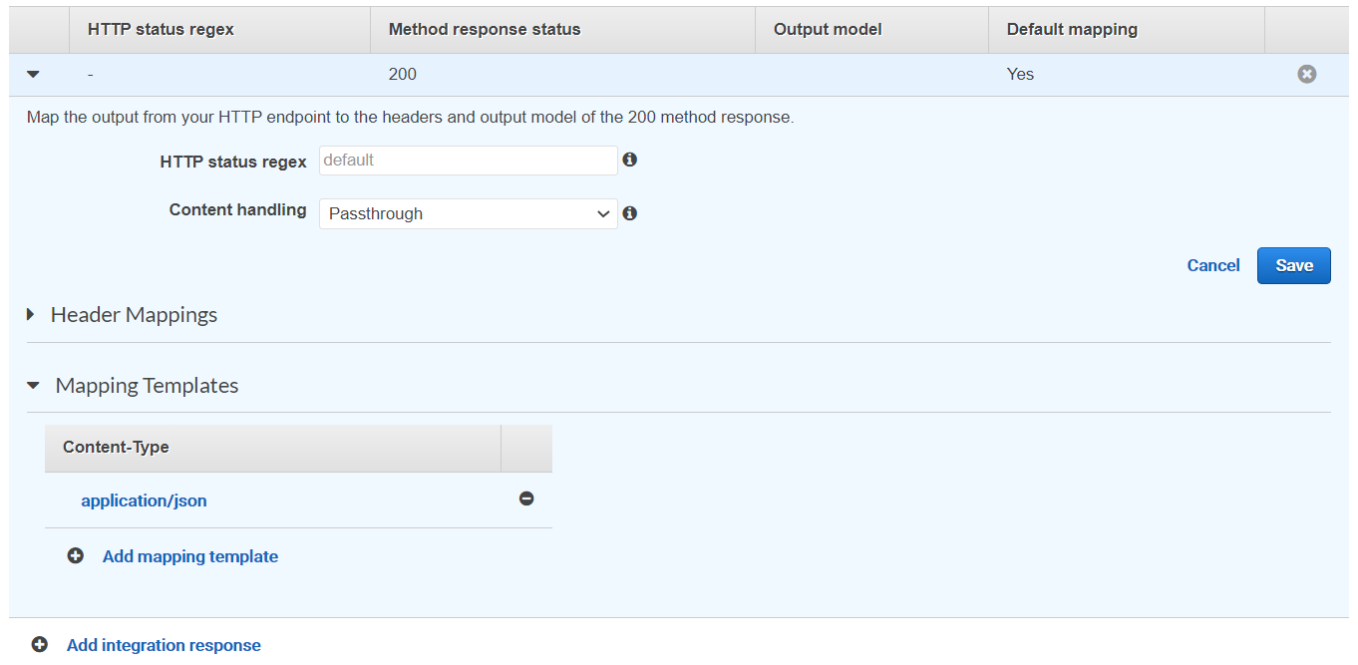

1. For “General template”, select “Method Request passthrough”
2. Replace all the lines with the following JSON:

[{

"file_id": "100",

"cloudinary_file_id": "Design/qcu5sbtct8htamip1cdw",

"cloudinary_url": "http://res.cloudinary.com/jonntan/image/upload/v1609597246/Design/qcu5sbtct8htamip1cdw.png",

"design_title": "rita design 1",

"design_description": "rita design 1 description text 1 text 2 text 3 text 4 ....",

"created_by_id": "100"

},

{

"file_id": "101",

"cloudinary_file_id": "Design/ct7pkxyeydpgjvctxk6r",

"cloudinary_url": "http://res.cloudinary.com/jonntan/image/upload/v1609597247/Design/ct7pkxyeydpgjvctxk6r.png",

"design_title": "rita design 2",

"design_description": "rita design 2 description text 1 text 2 text 3 text 4 ....",

"created_by_id": "100"

},

{

"file_id": "102",

"cloudinary_file_id": "Design/hzb1bqdtmv4tku8a0aiz",

"cloudinary_url": "http://res.cloudinary.com/jonntan/image/upload/v1609597249/Design/hzb1bqdtmv4tku8a0aiz.png",

"design_title": "rita design 3",

"design_description": "rita design 3 description text 1 text 2 text 3 text 4 ....",

"created_by_id": "100"

},

{

"file_id": "103",

"cloudinary_file_id": "Design/moywi2a3hqxh260zpgvk",

"cloudinary_url": "http://res.cloudinary.com/jonntan/image/upload/v1609597251/Design/moywi2a3hqxh260zpgvk.png",

"design_title": "rita design 4",

"design_description": "rita design 4 description text 1 text 2 text 3 text 4 ....",

"created_by_id": "100"

},

{

"file_id": "104",

"cloudinary_file_id": "Design/jhnt4upezo4gntyhkvpi",

"cloudinary_url": "http://res.cloudinary.com/jonntan/image/upload/v1609597252/Design/jhnt4upezo4gntyhkvpi.png",

"design_title": "rita design 5",

"design_description": "rita design 5 description text 1 text 2 text 3 text 4 ....",

"created_by_id": "100"

},

{

"file_id": "105",

"cloudinary_file_id": "Design/qynolnjubutq9i1a0aur",

"cloudinary_url": "http://res.cloudinary.com/jonntan/image/upload/v1609597254/Design/qynolnjubutq9i1a0aur.png",

"design_title": "rita design 6",

"design_description": "rita design 6 description text 1 text 2 text 3 text 4 ....",

"created_by_id": "100"

},

{

"file_id": "106",

"cloudinary_file_id": "Design/jsnr8g0pcdpxshc47alp",

"cloudinary_url": "http://res.cloudinary.com/jonntan/image/upload/v1609597255/Design/jsnr8g0pcdpxshc47alp.png",

"design_title": "rita design 7",

"design_description": "rita design 7 description text 1 text 2 text 3 text 4 ....",

"created_by_id": "100"

},

{

"file_id": "107",

"cloudinary_file_id": "Design/gbnpxpcqoj6tv9vjzgig",

"cloudinary_url": "http://res.cloudinary.com/jonntan/image/upload/v1609597257/Design/gbnpxpcqoj6tv9vjzgig.png",

"design_title": "rita design 8",

"design_description": "rita design 8 description text 1 text 2 text 3 text 4 ....",

"created_by_id": "100"

},

{

"file_id": "108",

"cloudinary_file_id": "Design/g7pbqtqbtatu73sqhubs",

"cloudinary_url": "http://res.cloudinary.com/jonntan/image/upload/v1609597258/Design/g7pbqtqbtatu73sqhubs.png",

"design_title": "rita design 9",

"design_description": "rita design 9 description text 1 text 2 text 3 text 4 ....",

"created_by_id": "100"

},

{

"file_id": "109",

"cloudinary_file_id": "Design/fn4thb1itvn8oje2ural",

"cloudinary_url": "http://res.cloudinary.com/jonntan/image/upload/v1609597260/Design/fn4thb1itvn8oje2ural.png",

"design_title": "rita design 10",

"design_description": "rita design 10 description text 1 text 2 text 3 text 4 ....",

"created_by_id": "100"

},

{

"file_id": "110",

"cloudinary_file_id": "Design/ztxlrezlx3okr4dargtk",

"cloudinary_url": "http://res.cloudinary.com/jonntan/image/upload/v1609597262/Design/ztxlrezlx3okr4dargtk.png",

"design_title": "rita design 11",

"design_description": "rita design 11 description text 1 text 2 text 3 text 4 ....",

"created_by_id": "100"

},

{

"file_id": "111",

"cloudinary_file_id": "Design/x35fi9d0tntzwer70c1k",

"cloudinary_url": "http://res.cloudinary.com/jonntan/image/upload/v1609597263/Design/x35fi9d0tntzwer70c1k.png",

"design_title": "rita design 12",

"design_description": "rita design 12 description text 1 text 2 text 3 text 4 ....",

"created_by_id": "100"

}]

1. Click grey “Save” button at bottom right
2. Click blue “Save” button on the top right and click “Method Execution” again
3. Click “TEST”
4. Scroll down. Under “Request Body”, enter the following JSON:

{

“file_id”: 100

}

1. Click the “Test” button. You should see all the JSON data stored: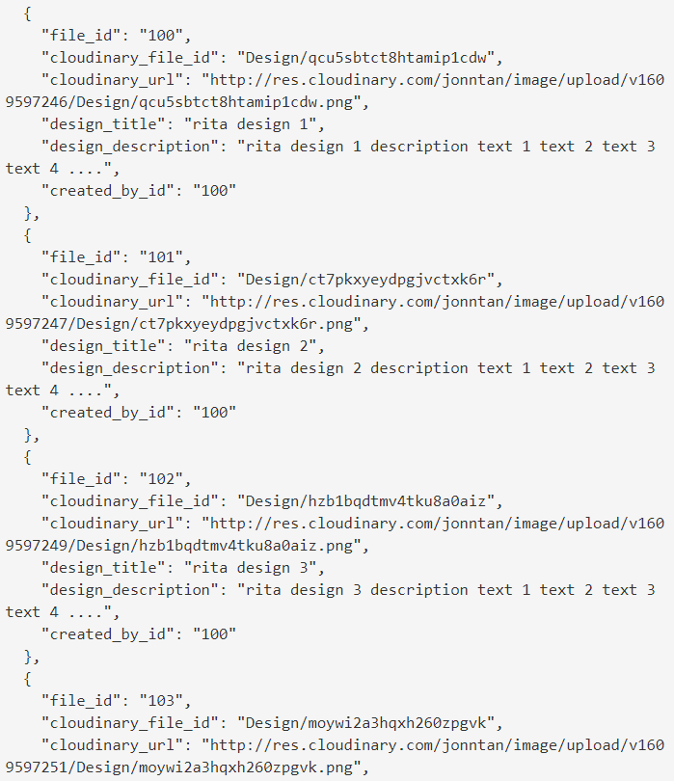
2. Next, to publish the REST API, under “Actions”, select “Deploy API”
3. On the “Deploy API” window, make the following changes:

Deployment stage: Select *[New Stage]*

Stage name: Enter *Prod*

Stage description: Enter *Prod*

Deployment description: Leave this box blank

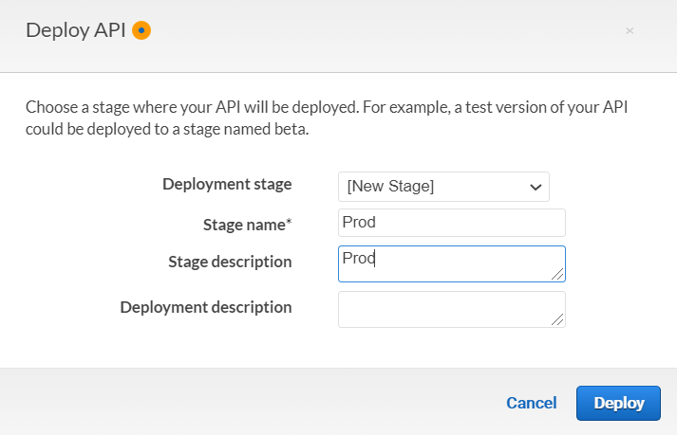

1. Click “Deploy” button and ignore any warnings
2. Take note of the “Invoke URL” displayed on the screen

**5.3 Connect the New API (Mock) Endpoint to Website**

1. In the AWS Cloud9 filesystem, there is a folder called *resources* and it consists of *cat_data.json, config.js* and *seed.js.* Double-click the *config.js* to open it.
2. Replace the <FMI> with the Invoke URL we previously took note of



1. Save the *config.js* file
2. In the code folder, double-click the upload_items file to open it.
3. Change the bucket_name_str with your S3 bucket name

Note: Make sure your file_path_str is “/home/ubuntu/environment/resources/” instead of “/home/ec2-user/environment/resources/” because we are using Ubuntu.

1. Run **node upload_items.js**



**5.4 Enable CORS on the Endpoint**

1. In the left navigation panel, go to “Resources” to view the “FileSearch” API
2. Choose “Actions” and select “Enable CORS”
3. Under “Gateway Responses for *FileSearch* API”, check both **DEFAULT 4XX”** and **“DEFAULT 5XX”**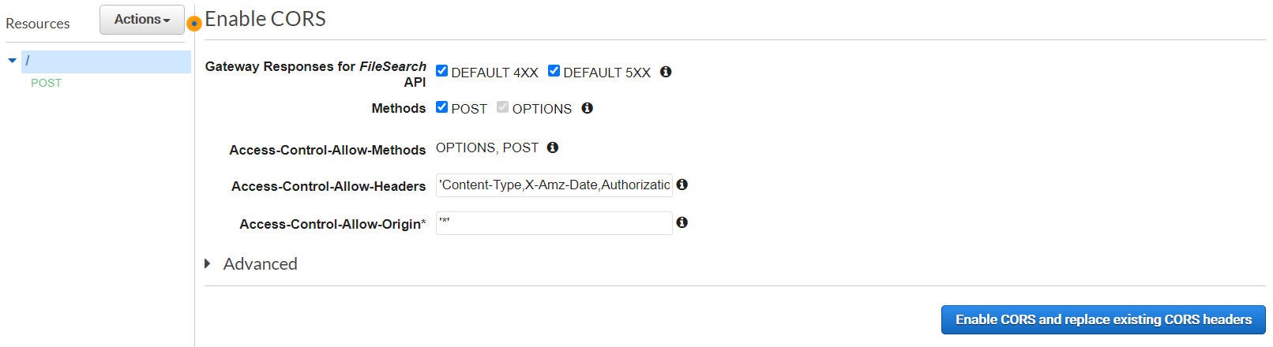
4. Leave other settings as it is and click “Enable CORS and replace existing CORS headers” button
5. Choose “Yes, replace existing values”
6. Choose “Actions” and then choose “Deploy API”
7. For “Deployment stage”, select Prod

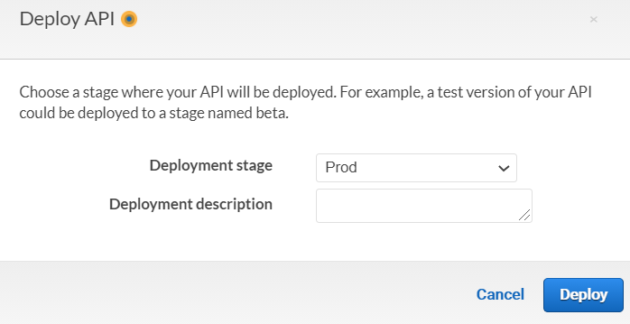

1. Click on “Deploy” button to deploy your prod stage (ignore any warnings)

**5.5 Create a Lambda Function that Queries a Database**

1. In the code folder, double-click the query_cats file to open it.
2. Change the code accordingly:

var

AWS = require("aws-sdk"),

DDB = new AWS.DynamoDB({

apiVersion: "2012-08-10",

region: "us-east-1"

});

function queryIndex(file_id, cb){

var

params = {

ExpressionAttributeValues: {

":file_id": {

N: file_id

}

},

KeyConditionExpression: "file_id = :file_id",

TableName: "file",

IndexName: "file_id"

};

DDB.query(params, function(err, data){

var

cat_reply_arr = [];

if(err){

throw err;

}

if(data.Items.length === 0){

return cb(null, []);

}

for(var i_int = 0; i_int < data.Items.length; i_int += 1){

cat_reply_arr.push(data.Items[i_int]);

}

cb(null, cat_reply_arr);

});

}

function scanTable(cb){

var

params = {

TableName: "file"

};

DDB.scan(params, function(err, data){

if(err){

throw err;

}

cb(null, data.Items);

});

}

(function init(){

var

file_id = "all",

cb = null;

if(process.argv[2] !== undefined){

console.log("Local test for " + process.argv[2]);

file_id = process.argv[2];

cb = console.log;

}else{

console.log("Running in lambda");

console.log(event);

cb = callback; //becomes available in lambda

file_id = event.file_id;

}

if(file_id === "All"){

scanTable(cb);

}else{

queryIndex(file_id, cb);

}

})();

1. Run **node query_cats.js “100”**
2. You should be able to retrieve the data of file_id “100”:

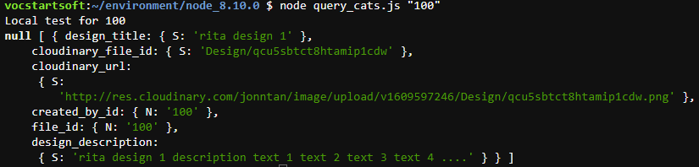

1. You can run **node query_cats.js “[file_id]”** to retrieve data under that particular file_id or you can also run **node query_cats.js “All”** to retrieve all data.

Note: The string “All” has to be in capitalised A.

This is how retrieving all data will look like:

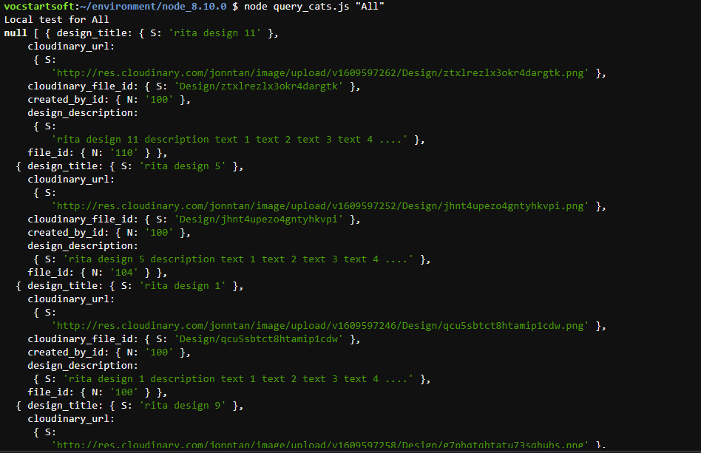

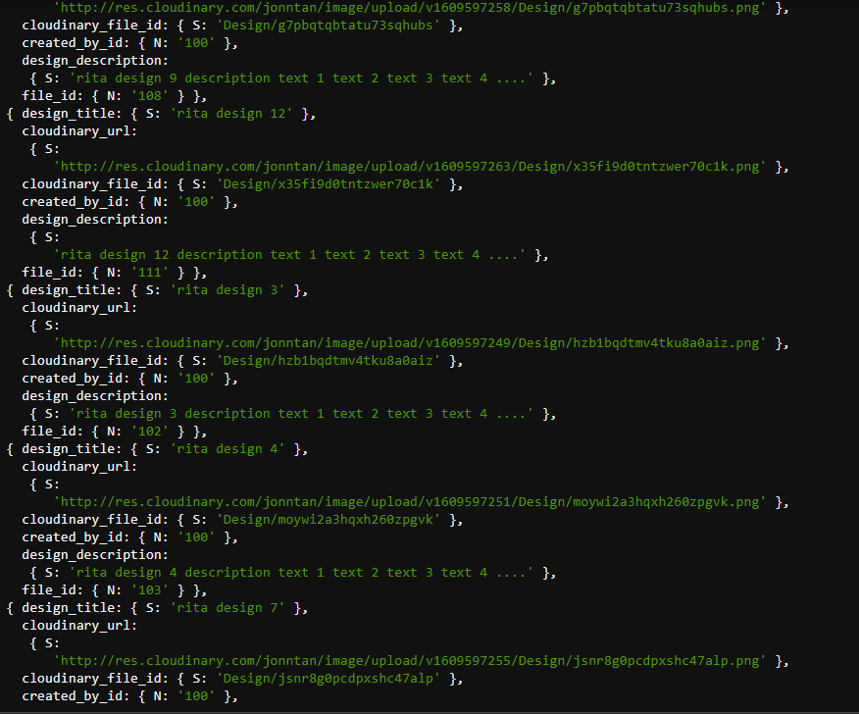

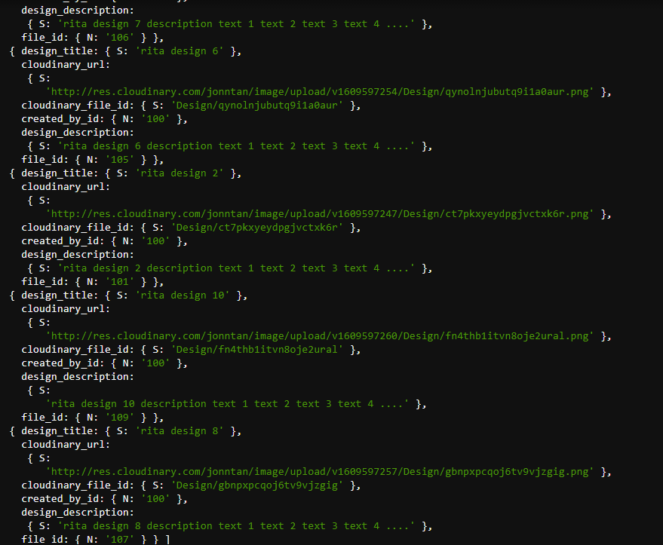

**5.6 Upload Lambda Deployment Package**

1. At the very top of the query_cats.js file, add this line:

**exports.handler = function(event, context, callback) {**

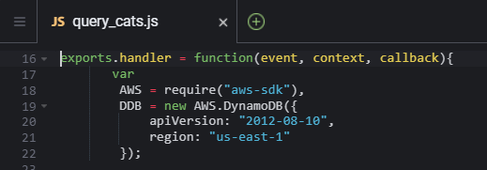

1. At the bottom of the file (after all your code), add this line:

**};**

1. Create a .zip file with your new query_cats code. Run the following code in the AWS Cloud 9 terminal:

**zip website_api_code.zip query_cats.js**



Note: Ensure that you entered the correct file ending (such as .rb or .js or .py)

You should be able to see the .zip file with the name *website_api_code.zip*

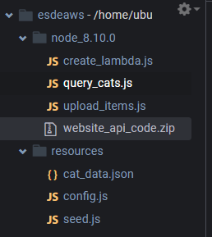

1. Double click upload_items.js to open it and make the following changes:
   1. For the *file_path* variable, replace **/home/ubuntu/environment/resources** with the string **./**
   2. For the *file_name* variable, replace **config.js** with **website_api_code.zip**
   3. Replace **text/javascript** with **application/zip**

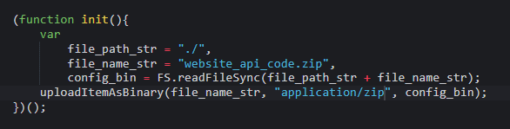

1. Run **node upload_items.js**



**5.7 Call Deployment Package and Configure Lambda Function**

1. Before you configure your lambda function, you will need to create an IAM role first.
2. Under AWS services, select **“IAM”**

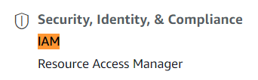

1. Under **“Access management”** (left panel), select **“Roles”**
2. Click on **“Create roles”** button
3. Select **“Lambda”** and click **“Next: Permissions”** button

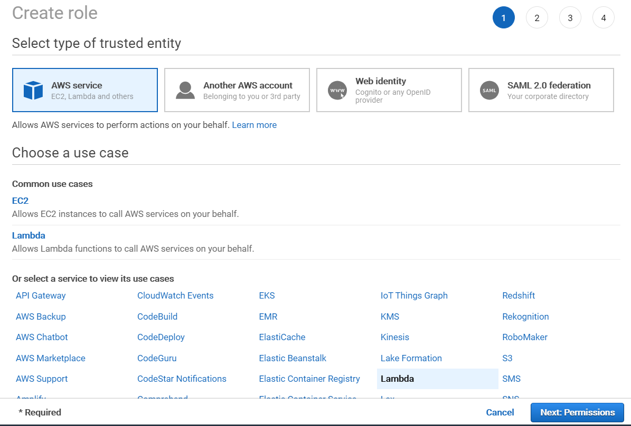

1. Search for **“AmazonDynamoDBFullAccess”** and **“AWSLambdaExecute”**, select them and click **“Next: Tags”** button

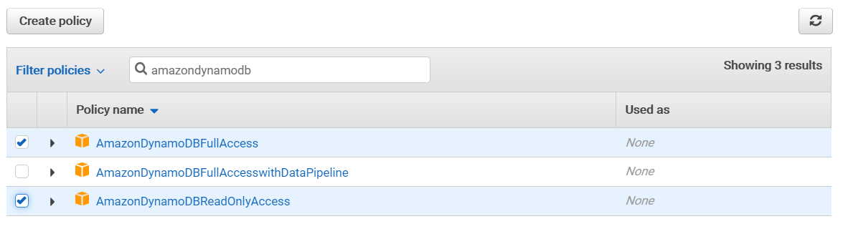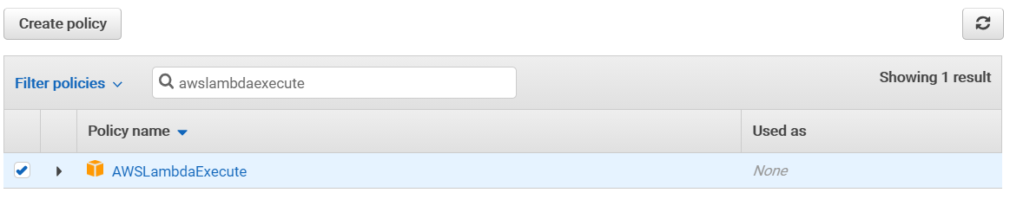

1. Click **“Next: Reviews”**
2. Change the role name to: **file-search-role-for-lambda**

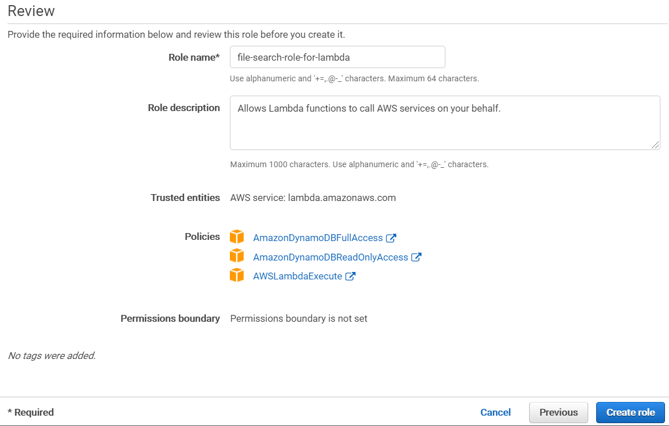

1. Click the **“Create role”** button. You should see that your role has been created:



1. Click the role and take note of the “Role ARN”: **arn:aws:iam::632251809605:role/file-search-role-for-lambda**

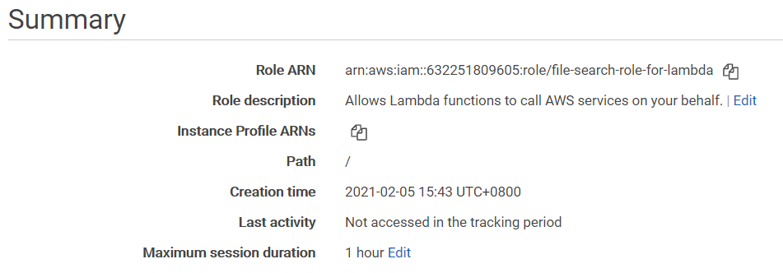

1. Back to Cloud9, in the code folder, double-click the create_lambda file to open it and make the following changes:
   1. For the *S3Bucket,* enter your own S3 Bucket name
   2. For the *FunctionName,* enter the API name we created previously
   3. For the *Role*, enter the Role ARN
   4. For the *Runtime*, change to **“nodejs12.x”**

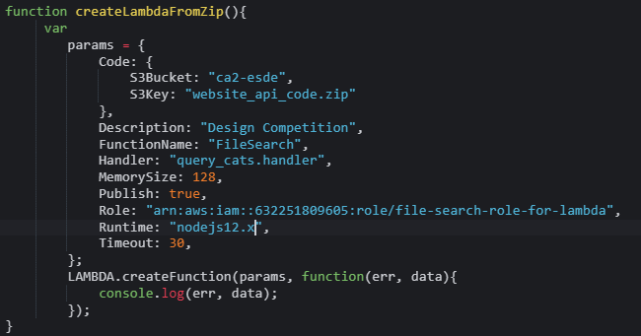

1. Run **node create_lambda.js**

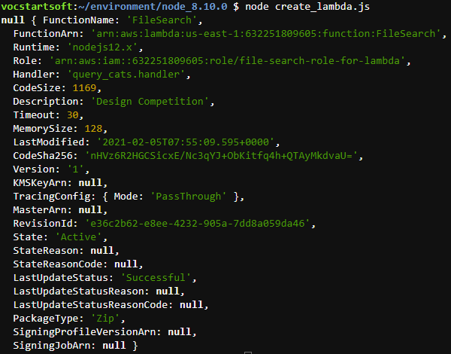

**5.8 Testing Lambda Function**

1. In the AWS Cloud9 terminal, enter the following command to search for *file_id “100”*:

**aws lambda invoke --function-name FileSearch --payload ‘{“file_id”: “100”}’ query_cat_results.json**

1. You should see the output as following:

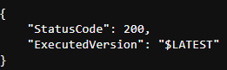

1. Open the query_cat_results.json and you should see the following:



1. Modify the command to see all the results:

**aws lambda invoke --function-name FileSearch --payload ‘{“file_id”: “All”}’ all_cat_results.json**

1. You should see the output as following:

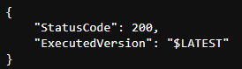

1. Open the all_cat_results.json and you should see the following:

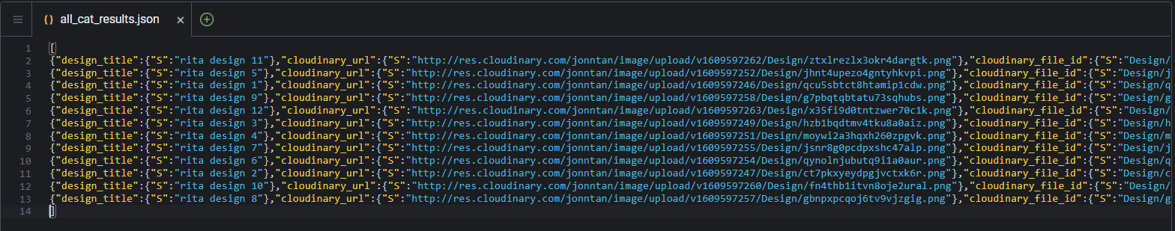

**5.9 Clean up AWS Cloud9 Environment**

1. To clean up the AWS Cloud9 environment, run the following command in the AWS Cloud9 terminal:

**aws s3 rm s3://[bucket name]/website_api_code.zip**



**5.10 Replace the REST API Mock Endpoint with New Lambda Function**

1. Under AWS services, select **“API Gateway”**
2. Select **“FileSearch”** API
3. Choose **“POST”** and then choose **“Integration Request”**
4. Make the following changes:
   1. For the “Integration type”, change **“Mock”** to **“Lambda Function”**
   2. For the “Lambda Region”, choose *us-east-1*
   3. For the “Lambda Function”, enter **“FileSearch”**

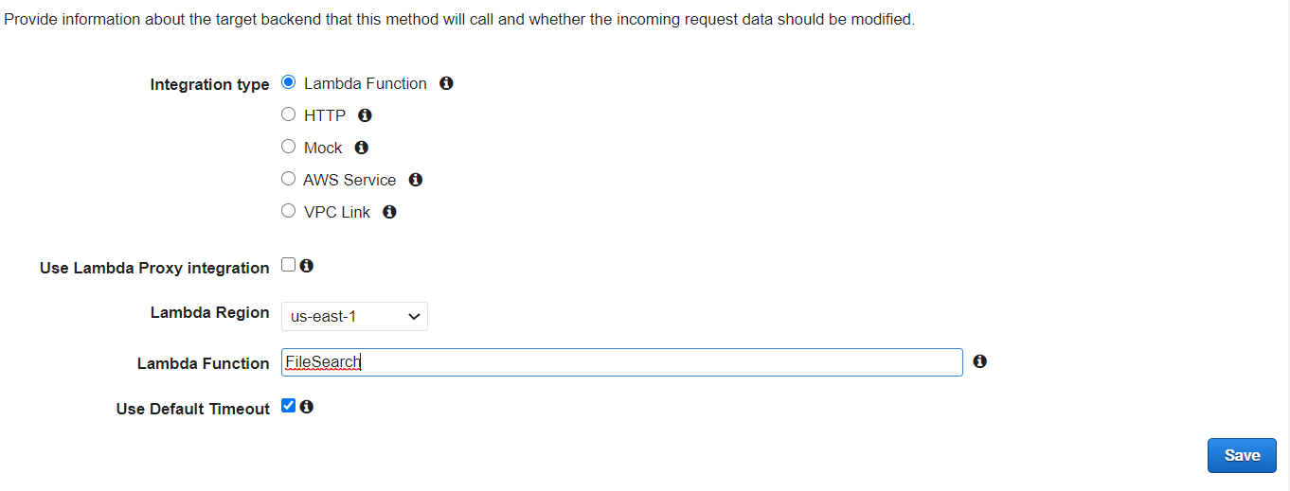

1. Click **“Save”** button
2. On the **“Switch to Lambda Integration”** window, choose **“OK”**
3. On the **“Add Permission to Lambda Function”** window, choose **“OK”**
4. At the top left, click **“Method Execution”**
5. Click **“TEST”**
6. In the “Request Body”, enter the following JSON:

{

“File_id”: “100”

}

1. You should be able to see the following results:

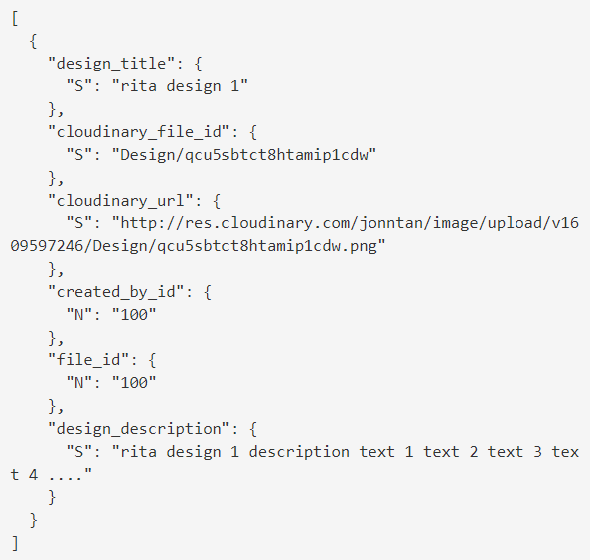

**5.11 Re-Enable CORS**

1. Choose **“Actions”** and choose **“Enable CORS”**
2. Under “Gateway Responses for *FileSearch* API”, check both **DEFAULT 4XX”** and **“DEFAULT 5XX”**
3. Leave other settings as it is and click “Enable CORS and replace existing CORS headers” button
4. Choose “Yes, replace existing values”
5. Choose “Actions” and then choose “Deploy API”
6. For “Deployment stage”, select Prod



1. Click on “Deploy” button to deploy your prod stage (ignore any warnings)

**5.12 Test Website**

1. You should be able to login the website by keying in the following:

Email: [rita@designer.com](mailto:rita@designer.com)

Password: password

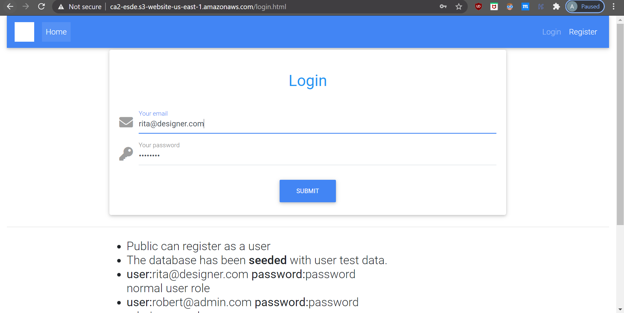

1. You will be brought to the manage_submission.html page after successful login:

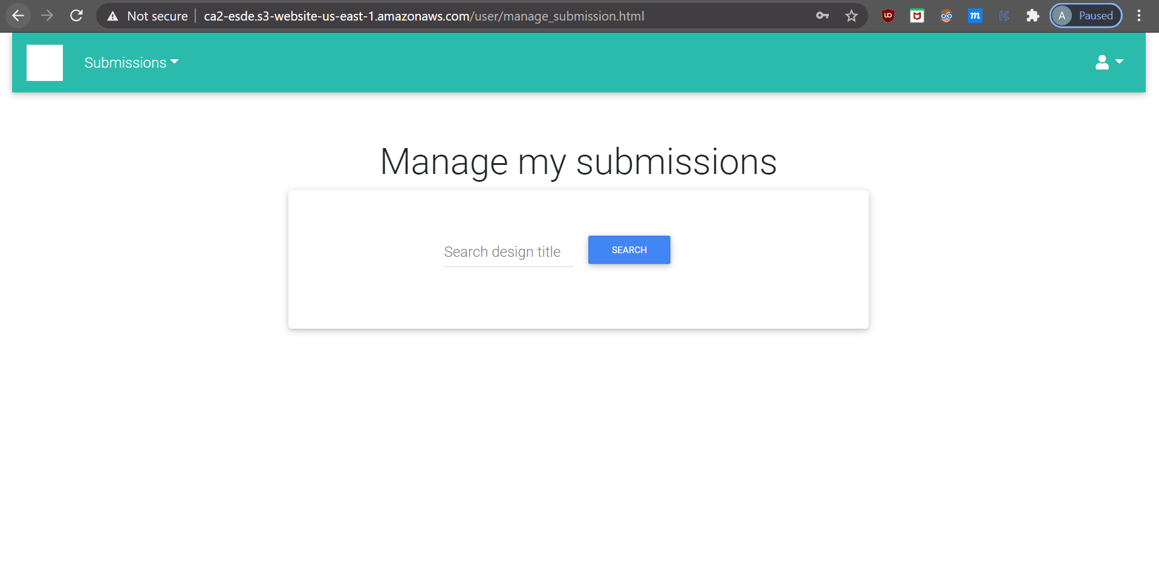

1. If you key in an invalid email and password, an “error” message will pop out:

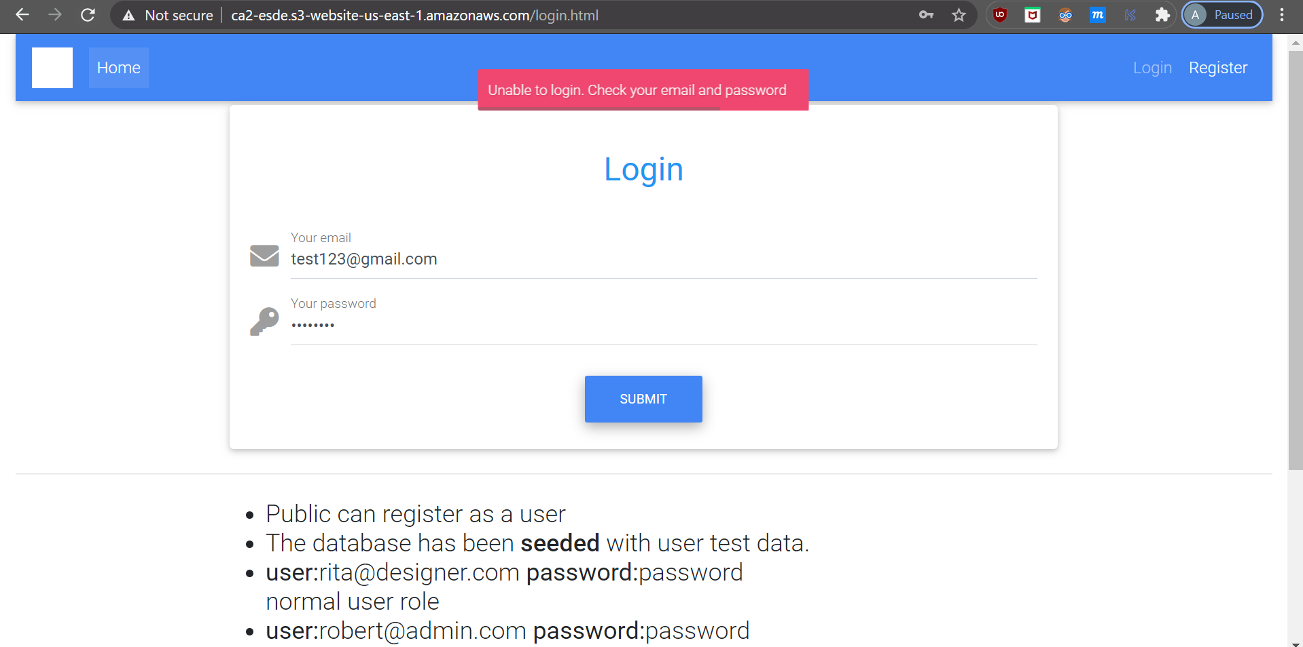

1. After logging in, you should be able to see that the website is able to work and is displaying all the data after you press the “Search” button: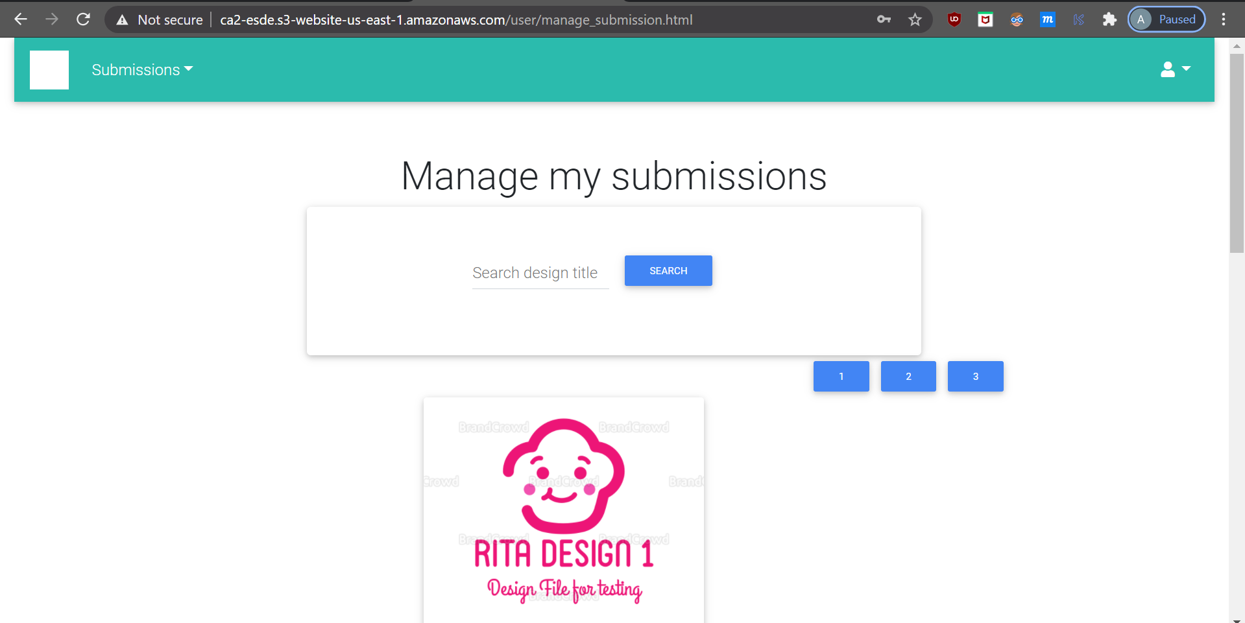

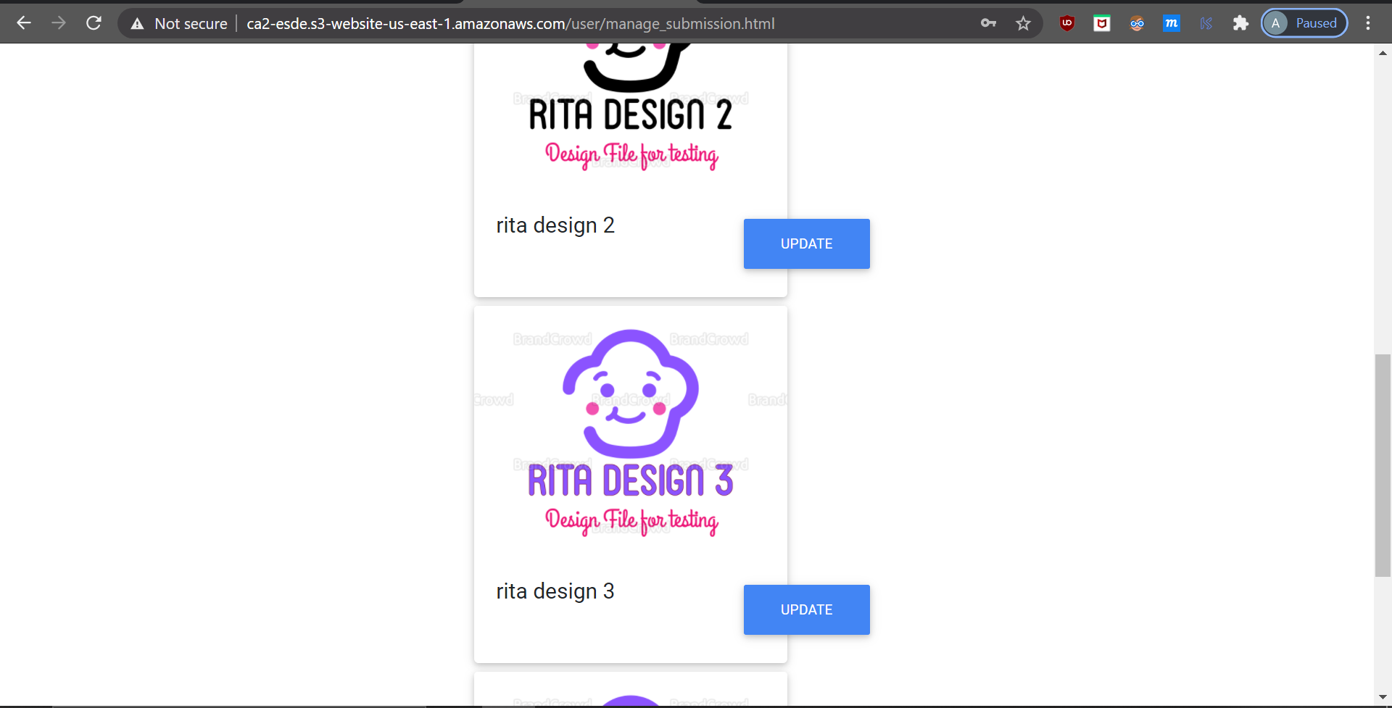

**6.0 Troubleshooting**

**6.1 Elastic IP**

**Problem:** When an instance is terminated the public IP attached to it gets released and further when you relaunch the same instance a new IP address is assigned.

**Solution:** Elastic IP does not change and they remain the same even if you terminate the instance and later again restart the same instance.

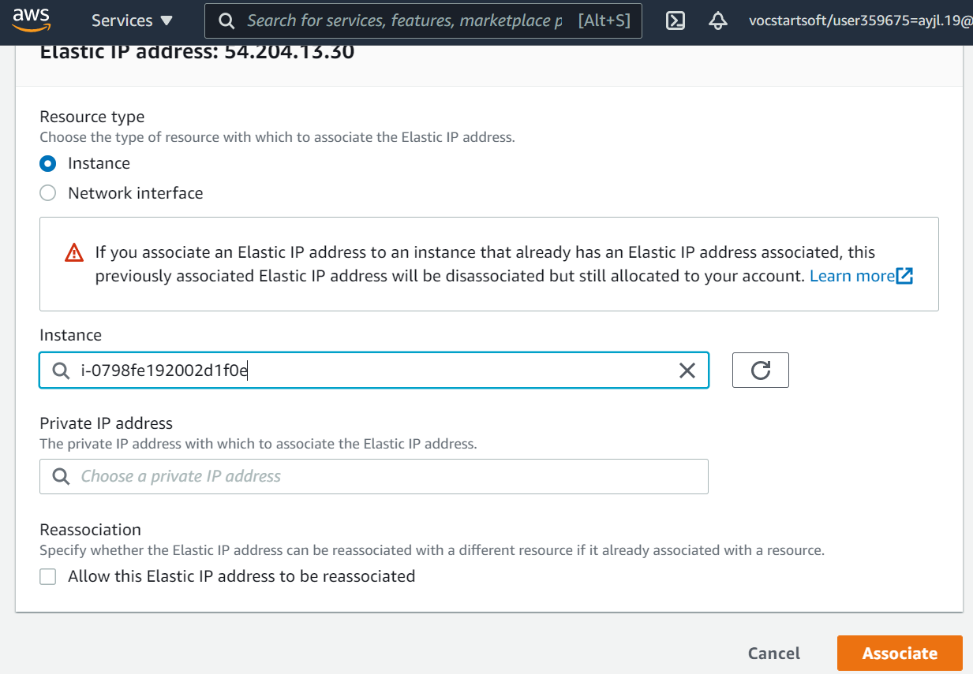

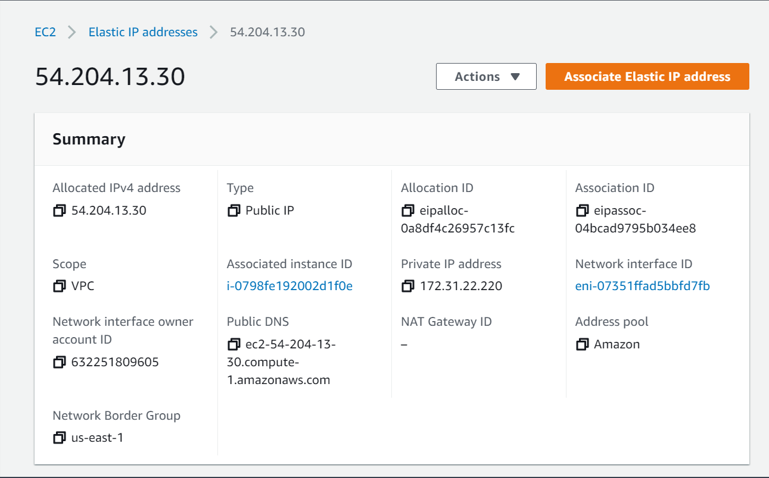

**6.2 Putty SSH Connection Never to Timeout When User is Idle**

**Problem:** Putty SSH Connection timeouts when the user is idle.

**Solution:**

1. Go to Putty “Settings” -> “Connection”.
2. Set the value of “Seconds between keepalives” to 30 seconds.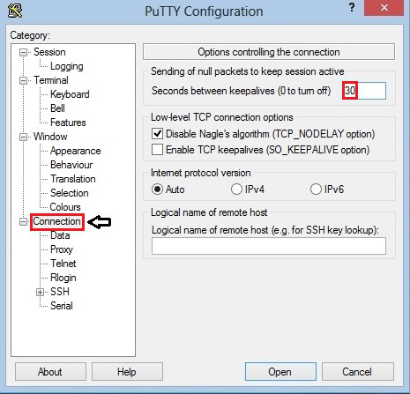

**6.3 Error Running Command in Cloud9**

**Problem:** Error occur when running **“wget https://aws-tc-largeobjects.s3-us-west-2.amazonaws.com/DEV-ILT-TF-200-ACCDEV-1/lab-3-ddb.zip -P /home/ec2-user/environment”** command:

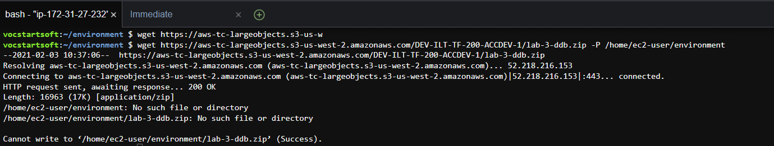

**Solution:** Ensure that you are running in the right directories: /home/ubuntu/environment

New Command: **wget https://aws-tc-largeobjects.s3-us-west-2.amazonaws.com/DEV-ILT-TF-200-ACCDEV-1/lab-3-ddb.zip -P /home/ubuntu/environment**

Note: We created Cloud9 using ubuntu and not using Amazon Linux AMI, hence, if you are using Linux, default user is ec2-user.

**6.4 Error 502 CORS Headers Missing**

**Problem:** Error 502 message whereby access is blocked by CORS policy. Example of Error 502 is as following:

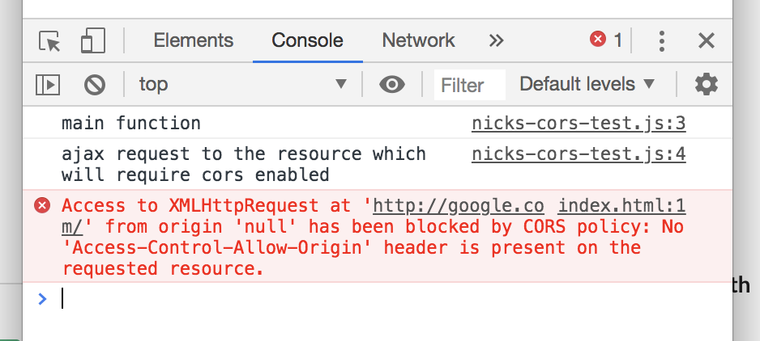

**Solution:**

1. Under AWS services, go to “API Gateway” and navigate to your API.
2. Choose **“Actions”** and choose **“Enable CORS”**
3. Under “Gateway Responses for *FileSearch* API”, check both **DEFAULT 4XX”** and **“DEFAULT 5XX”**
4. Leave other settings as it is and click “Enable CORS and replace existing CORS headers” button
5. Choose “Yes, replace existing values”
6. Choose “Actions” and then choose “Deploy API”
7. For “Deployment stage”, select Prod



1. Click on “Deploy” button to deploy your prod stage (ignore any warnings)

**6.5 Can’t access DynamoDB from Lambda Function**

**Solution:** You need to grant Lambda functions permissions to write to DynamoDB.

1. Under AWS services, select **“IAM”**
2. Under **“Access management”** (left panel), select **“Roles”**
3. Click on **“Create roles”** button
4. Select **“Lambda”** and click **“Next: Permissions”** button



1. Search for **“AmazonDynamoDBFullAccess”** and **“AWSLambdaExecute”**, select them and click **“Next: Tags”** button



1. Click **“Next: Reviews”**
2. Change the role name to: **file-search-role-for-lambda**



1. Click the **“Create role”** button. You should see that your role has been created:



1. Click the role and take note of the “Role ARN”: **arn:aws:iam::632251809605:role/file-search-role-for-lambda**



Note: The Role ARN is needed when creating the Lambda function.

**6.6 Node Version Outdated**

1. Launch your PuTTy.
2. Run **nvm version** to check your node version because previously we have installed v8.10.0 which is outdated and may affect the project.

Note: Ignore Step 3-6 if your node version is v10.16.3 and above.

1. If your node version is outdated, run **sudo apt-get remove nodejs**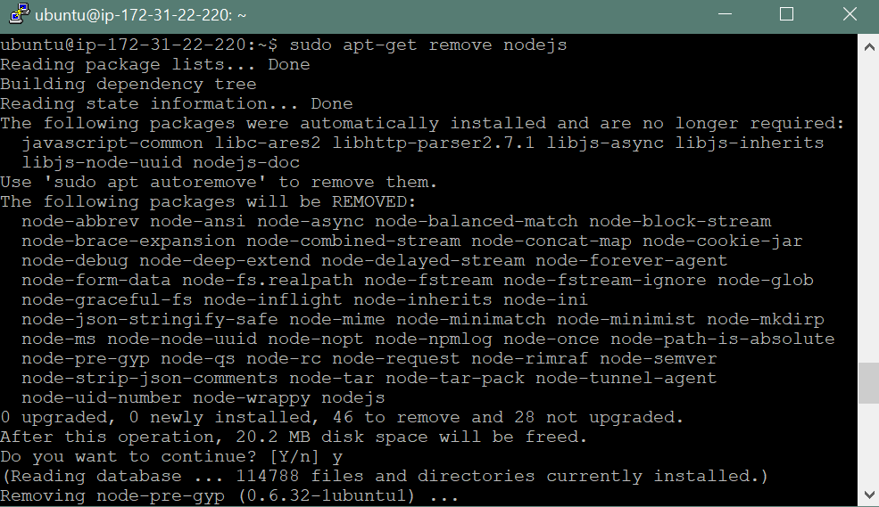
2. When prompted “Do you want to continue?”, key in the string ‘y’ and enter.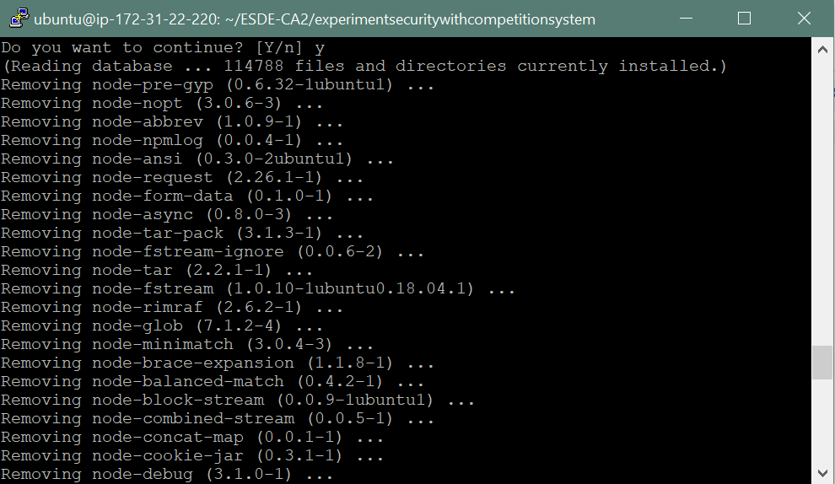
3. Run **nvm install node 15.8.0**

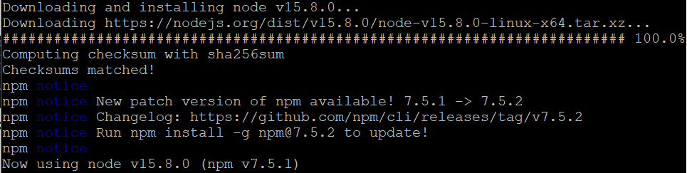

1. Run **nvm version** to check the current node version



**6.7 Unable to Login**

**Problem:** Unable to login due to connection error.

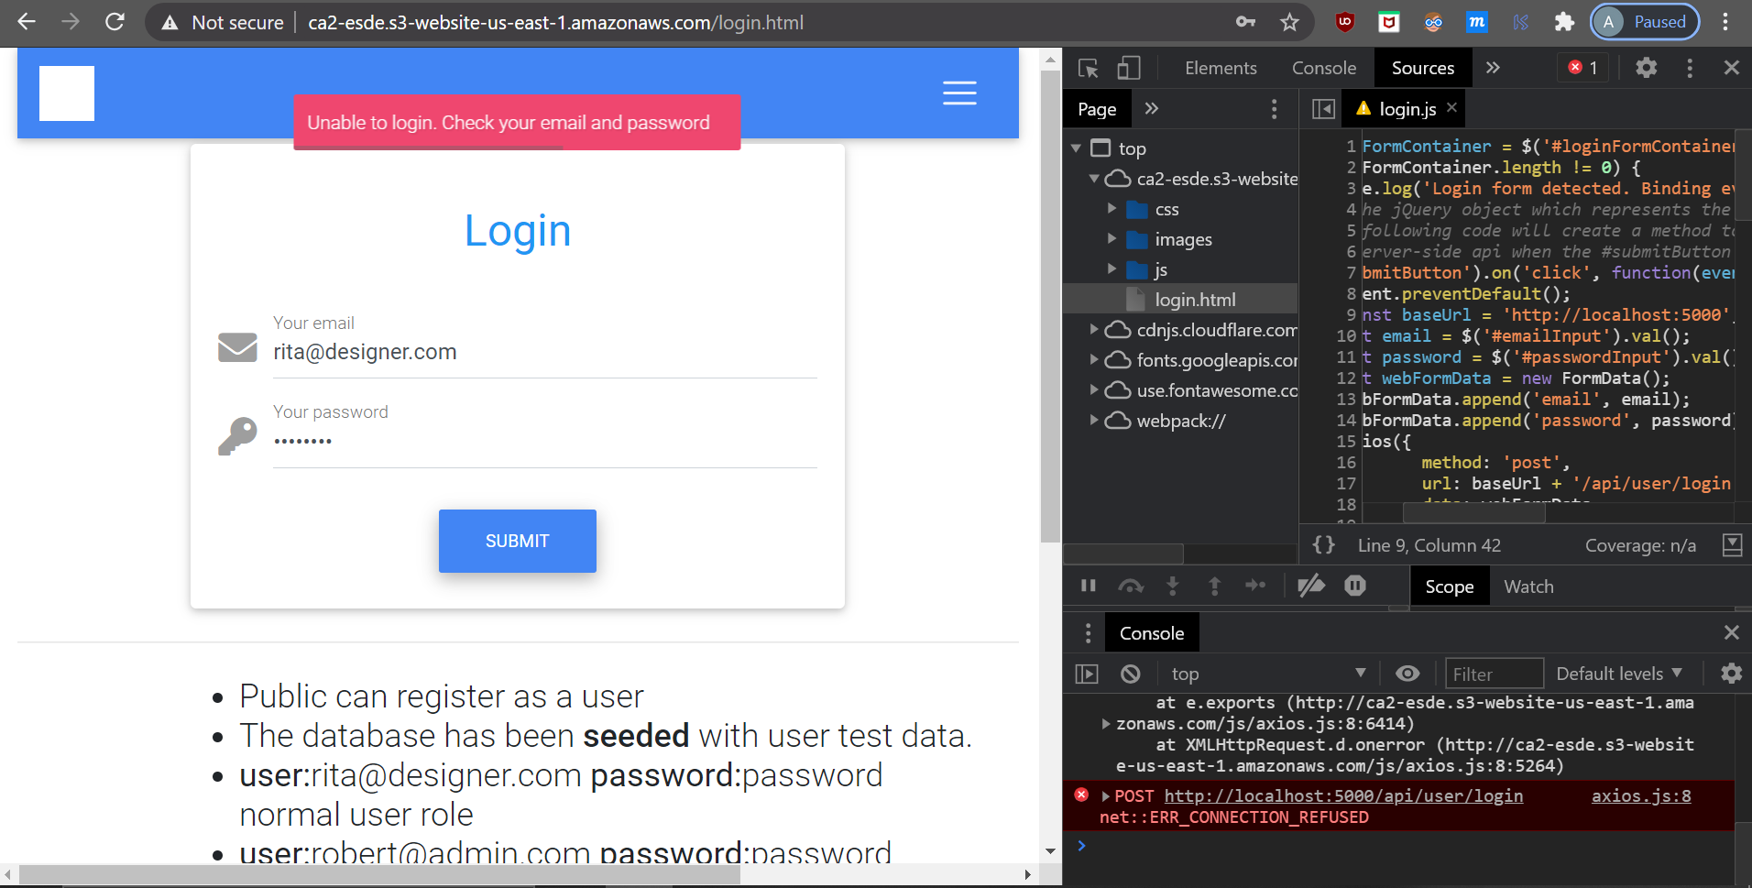

**Solution:**

1. Press F12 to open the Inspector Tab.
2. Navigate to /js/login.js and check the baseUrl. Make sure that the baseUrl is the same as the EC2’s IP (*http://54.204.13.30:5000*) instead of *http://localhost:5000*

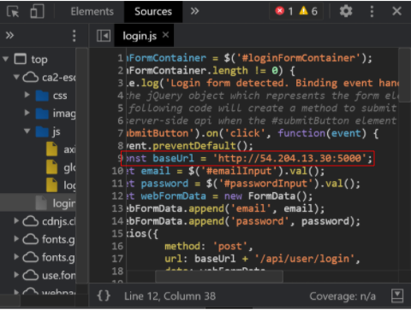

1. After the changes, you should be able to see that the login is successful unless you key in an invalid email and password. You will be redirected to the manage_submission.html.

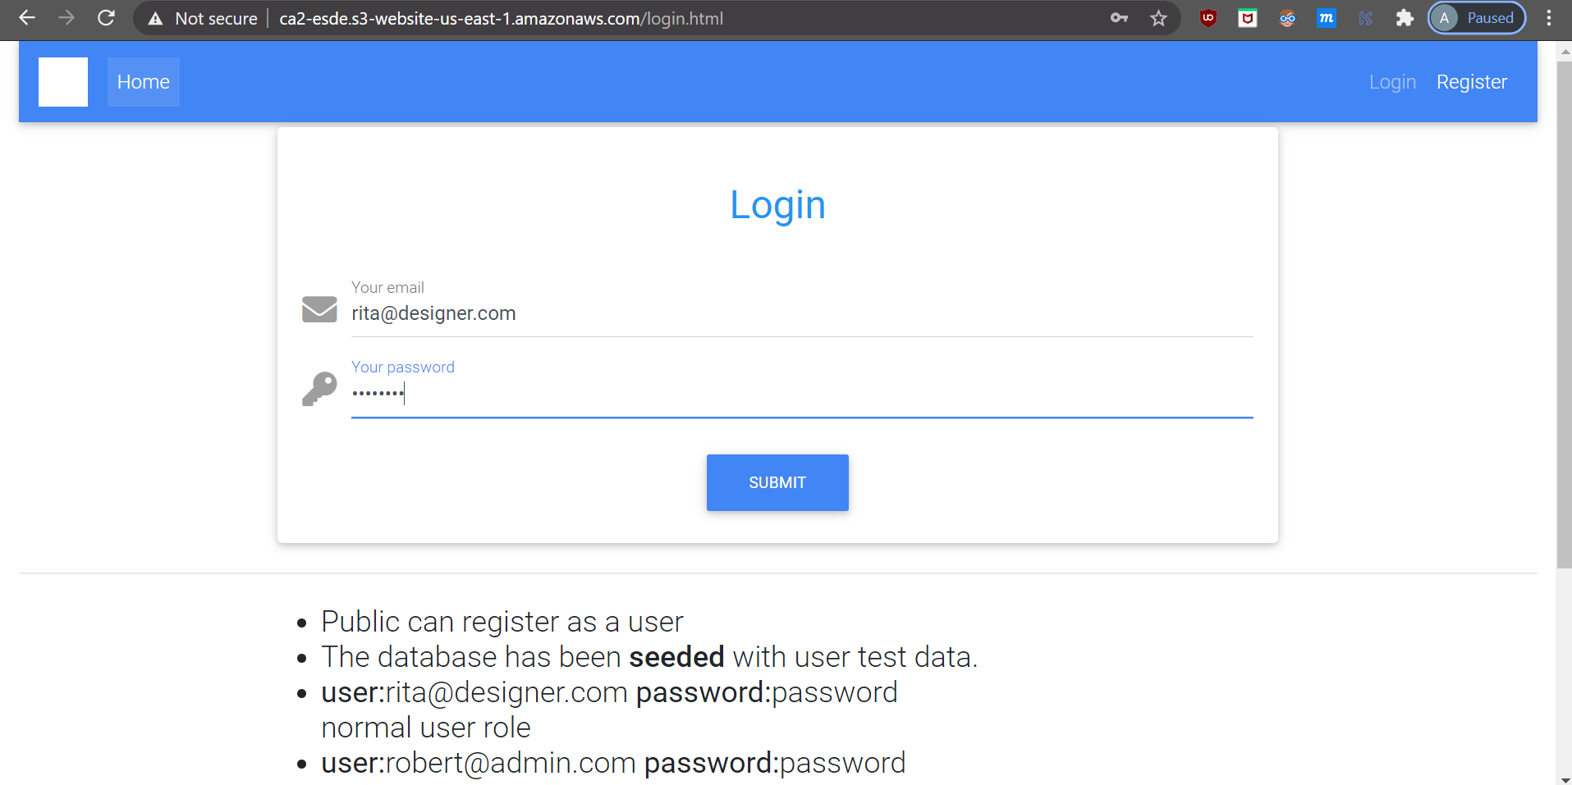

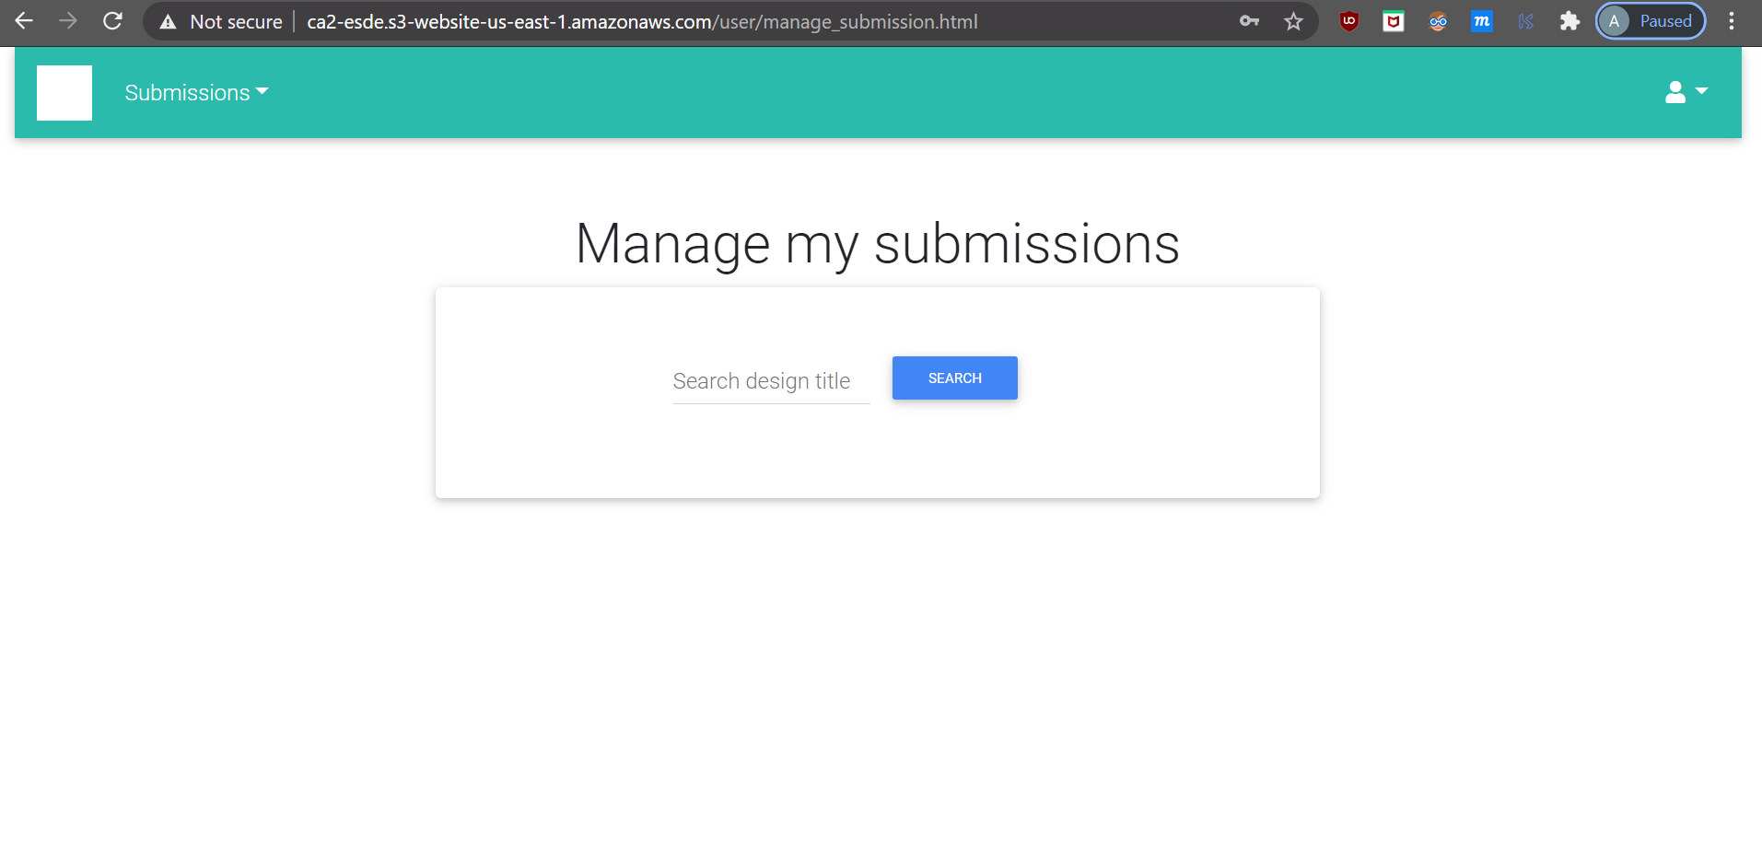

**6.8.1 Unable To Show Item in Website Part 1**

**Problem:** Items (in the case of our project, the designs) are not displaying after clicking on the “Search” button.

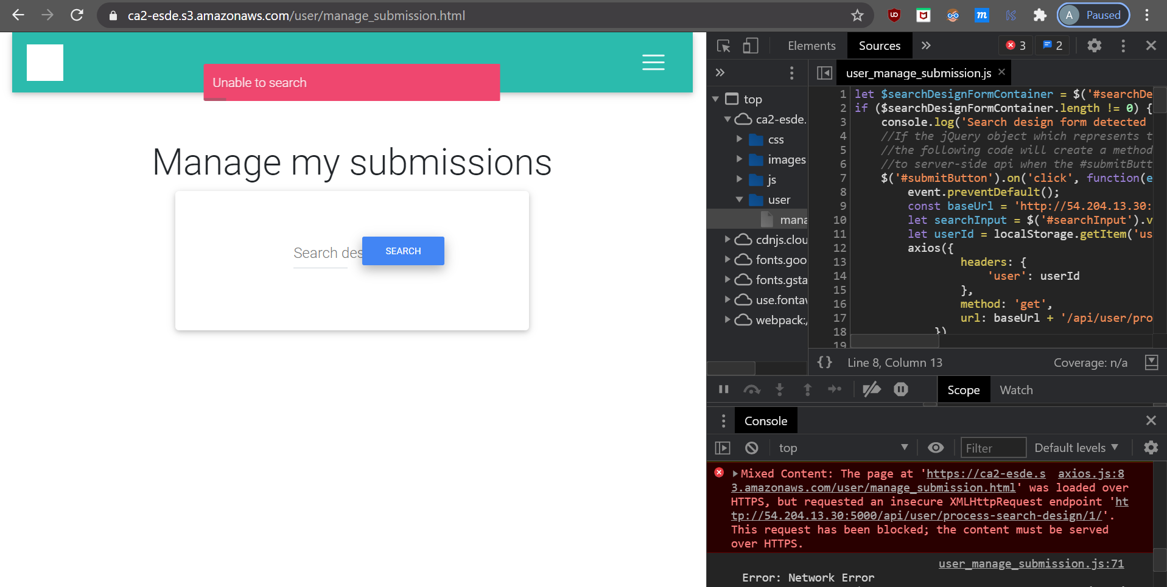

**Solution:**

1. Navigate back to the login page and login as a user before trying to search for an item.

The manage_submission.html only displays the users’ own submissions, hence new users have to register for an account, submit a submission before he/she can view their own submission. Similarly, users with existing accounts have to login first before he/she can view their own submissions.



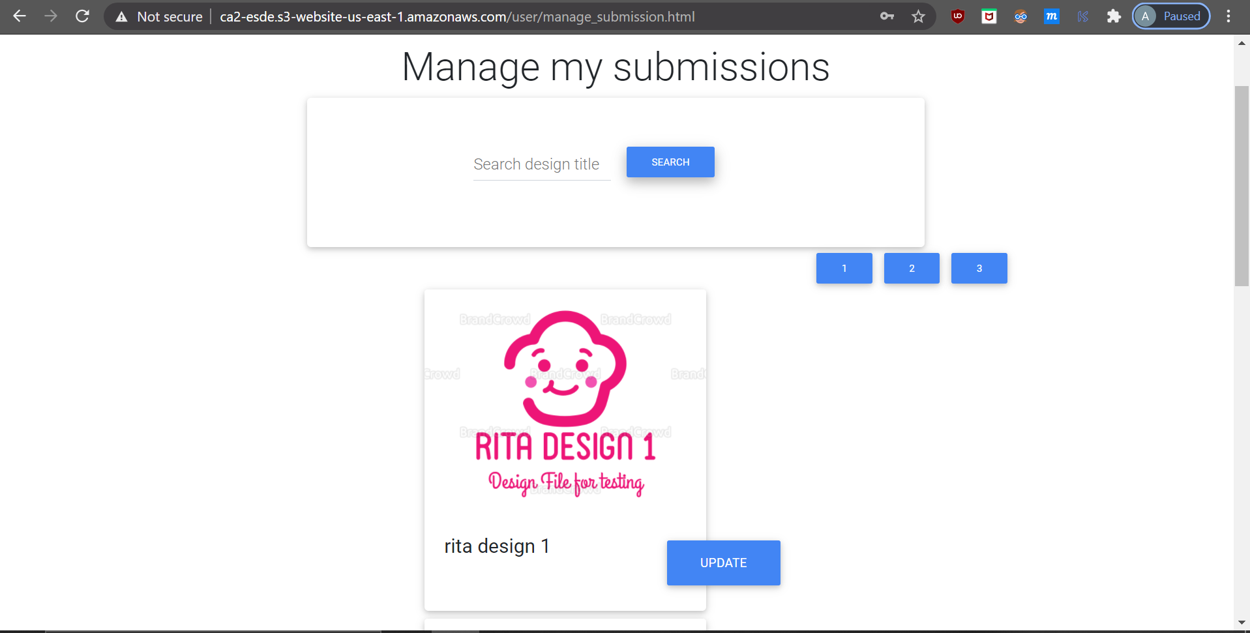

**6.8.2 Unable To Show Item in Website Part 2**

**Problem:** Items (in the case of our project, the designs) are not displaying after clicking on the “Search” button due to connection error.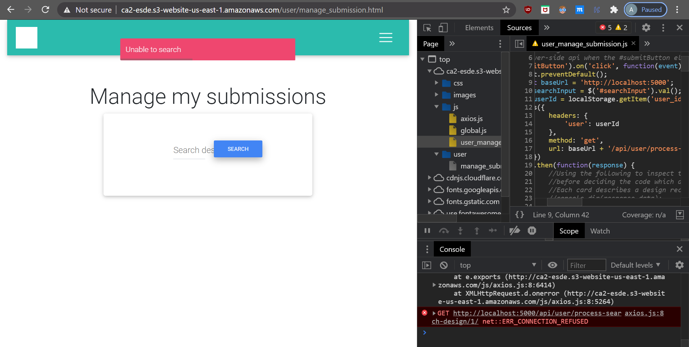

**Solution:**

1. Press F12 to open the Inspector Tab.
2. Navigate to user_manage_submission.js and check the baseUrl. Make sure that the baseUrl is the same as the EC2’s IP (*http://54.204.13.30:5000*) instead of *http://localhost:5000*

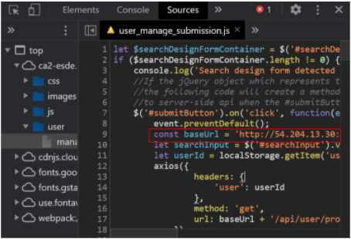

1. After the changes, you should be able to see the designs being displayed.

